# Introduction

This chapter describes firstly the key results of the analysis of the survey data gathered through online questionnaires, then statistically tests the hypotheses, and, lastly, presents a statistical model to approximate the contribution of SNSF-funded projects to social innovation (SI).

An invitation to participate in the survey went out to roughly 1000 principal investigators who were selected based on an *informed sampling* of a corresponding number of SNSF-funded research projects.

To ensure a representative sample of projects, the following criteria were taken into consideration:

* *Gender*
* *Scientific domain*
* *Institution Type*
* *Funding instrument[[1]](#footnote-1)*
* *Year of completion*

The last item, i. e. the *year of completion*, was not a sampling criterion in the strict sense; its main purpose was to increase the number of insights to be gained from the survey participants. The specific time frame of the scrutinised SNSF funded projects (2015 to 2019) was jointly determined by the SNSF and the study team, based on the assumption that the sampled projects were recent enough that the interviewees would remember the specifics, but long enough in the past that conclusions regarding potential (non-academic) *project outcomes* can be drawn.

Similarly, it was deemed an acceptable compromise to have an over-representation of *Sinergia* projects. Projects belonging to this funding instrument tend to have a wider participation in terms of involved stakeholder groups than those belonging to a different funding instrument.

The response rate amounted to 36 %. The gender-related shares and the shares related to the scientific domains found in the sample are reflected among the survey respondents. To be more specific, the share of female researchers is 21 % in case of the sample and 23 % in case of the survey respondents (see Table 1). The share of scientific domains varies to a minor degree, i. e. between 2-5 %, when comparing the sample and survey respondents (see Table 2). This means that the scientific domain *Biology and Medicine* was marginally underrepresented while the other two domains were slightly overrepresented.

Table 1: Comparison of the sample and survey respondents in terms of gender

|  |  |  |  |
| --- | --- | --- | --- |
| Gender | Sample  (n = 1002) | Respon­dents  (n = 361) | Visualisation |
| *Female* | 21 % | 23 % |  |
| *Male* | 79 % | 77 % |

Table 2: Comparison of the sample and survey respondents in terms of scientific domains

|  |  |  |  |  |  |  |
| --- | --- | --- | --- | --- | --- | --- |
| Scientific Domain | Sample  (n = 1002) | | Respon­dents  (n = 361) | | | Visualisation |
| *Biology and Medicine* | | 35 % | | 30 % |  | |
| *Humanities and Social Sciences* | | 32 % | | 35 % |
| *Math., Nature, and Engineering Sciences* | | 33 % | | 35 % |

# Methodology

The main challenge of exploring SI in connection with SNSF-funded research projects lies in the operationalisation of SI concepts found in scientific literature. To meet this challenge, we conducted an extensive literature research to determine the primary variables that contribute to or support SI. Through a series of expert workshops, those variables were then operationalised to make it possible to gauge them through online questionnaires.

The study’s overall methodological approach is described in previous chapters. This section focuses on the detailed description of methods applied, assumptions made, and decisions taken specifically in the context of the survey data analysis.

The vast majority of survey questions was posed to test specific hypotheses. While some questions served to test whether responses were significantly different between scientific domains[[2]](#footnote-2), others served to examine relations/correlations between different variables covered by the survey questions.

Some of the variables showed too little variation for hypothesis testing (e. g. high similarity in age groups of the respondents makes the variable ineligible to base hypothesis on). That being said, the vast majority of hypotheses could be tested based on the survey results.

Before conducting statistical tests, the frequencies of the surveyed items were considered to decide on the appropriate hypothesis testing methods. We used non-parametric statistical tests, because the responses to the survey items were not normally distributed. Spearman correlations were employed for testing associations between variables and … to test for differences between variables. For the analysis, the hypothesis testing, as well as the visualisation of results, the statistical programming language R was used, as well as occasional Python scripting.

Considering the rich number of the SI aspects, and in relation, to the wide scope of the survey questions, survey results have produced a fairly large dataset with a high number of features. For the model building, an extensive dimension reduction process comprising *Principal Feature Analysis* (PFA(Lu et al., 2007)) was applied to determine feature importance in order to eliminate the least *important* ones. Furthermore, *Explanatory* and *Confirmatory Factor Analysis* (EFA, CFA) methods were used to represent a large number of features in a fewer number of factors. The representative model produced by the factor analysis process has been used as a basis to create an *SI-Index* that categorises the examined projects in terms of their contribution to SI.

The final hypothesis of the study concerns with the comparison of the SI-Index created through our modelling process and the contribution to SI-Rating entered by each survey respondent for their project (for a detailed analysis of the survey question, see Section 3.2.3: Project’s contribution to SI (self-assessment)). The ambition for the comparison is to find out if there is any significant over- or understatement regarding the self-assessed SI-Rating.

# Analysis of the survey questions

This section is structured along the thematic grouping of the online survey:

* “Demographic” data
* Self-assessment
* Intention and agency
* Transdisciplinary aspects
* Regulatory framework
* Outcome-orientation
* Dissemination and exploitation

Correspondingly, the analysis results for each of these groups are presented individually in the following sections and sub-sections.

## Age/ Academic Age

Since we were targeting Principal Investigators (PIs) of SNSF funded projects, unsurprisingly the vast majority of respondents (~ 95 %) are in their forties, fifties, or sixties (see Figure 1). The *fifties* category is the most frequently selected one (159), followed by the *sixties* (106), and the *forties* (77).

While the *nominal* *age* distribution resembles a *normal distribution*, the *academic age* is highly skewed towards the upper end: nearly 90 % of respondents belong to the “> 15 years” category of experienced academics/scholars. Additional answer categories would have allowed a more nuanced analysis. As it stands, this variable has limited value and, consequently, was not used in the hypothesis testing.

Figure 1: Distribution of nominal age and academic age among the respondents (n = 361)

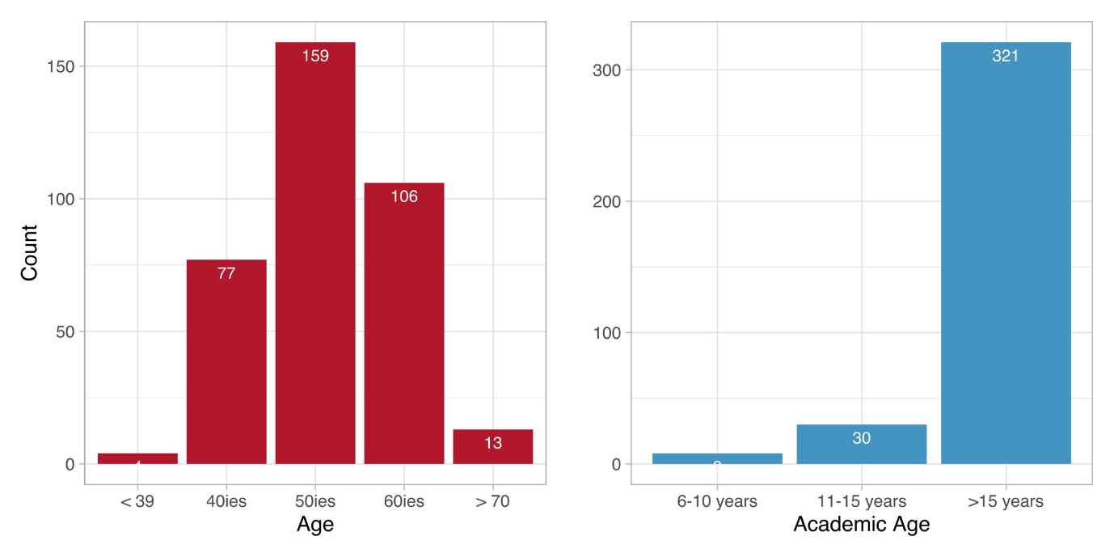

Table 3: Distribution of age among the respondents (n = 361)

|  |  |  |
| --- | --- | --- |
| response | abs | % |
| 39 or younger | 4 | 1.11 % |
| 40 to 49 | 77 | 21.45 % |
| 50 to 59 | 159 | 44.29 % |
| 60 to 69 | 106 | 29.53 % |
| 70 or older | 13 | 3.62% |
| *no response* | *2* |  |

## Familiarity with transdisciplinarity research and SI

This group of questions comprises three self-assessment items:

* the respondent’s experience with transdisciplinary research,
* their familiarity with the concept of SI, and
* their assumed project’s contribution to SI.

These variables will be vital in the hypothesis testing, as they reflect the respondent’s view on their own competencies and achievements, a self-assessment that can then be contrasted with their responses on other potential key factors, such as the project’s non-academic outcomes or the inclusion of non-academic actors in their SNSF funded projects. More information on the testing of the hypotheses can be found in chapter 4; this chapter shows first the results of the descriptive statistics.

The first variable to analyse in this group of question is *experience with* *transdisciplinary research*. There are several ways to approach the concept of transdisciplinarity. In the context of this study we refer to the Swiss Academy of Sciences who understands[[3]](#footnote-3) *transdisciplinary research* as research linking “[…] *societal problem solving with scientific knowledge production in a process of co-producing knowledge*.”

Scholarly literature goes as far as stating that *transdisciplinary aspects* are central (and necessary) to SI-related research. Thus, it could be argued that *transdisciplinarity* ought to be regarded as a potentially important indicator for SI-relevant outcomes. In contrast to this notion, however, our theoretical framework does not consider *transdisciplinary involvement* a necessary prerequisite for research projects to contribute to SI. That said, we still expect it to be more influential than other factors (for a more detailed exploration, see Section 3.2.1).

When asked about their ***experience with transdisciplinary research***, 48 % of respondents stated that they are indeed experienced (7 and above on a 0-10 scale; 10 being the maximum), 26 % replied to be somewhat experienced, and another 26 % that they were not experienced (3 and below; 0 being the minimum). Figure 2 (first row) provides a visual overview on this distribution, while Table 4 (left columns) details all the responses in each category separately. The latter also shows that, out of 361 overall survey participants, 352 chose to answer this particular question, while 9 refrained from ansering.

Figure 2: SI-familiarity, familiarity with transdisciplinarity, and project’s contribution to SI (self-assessment)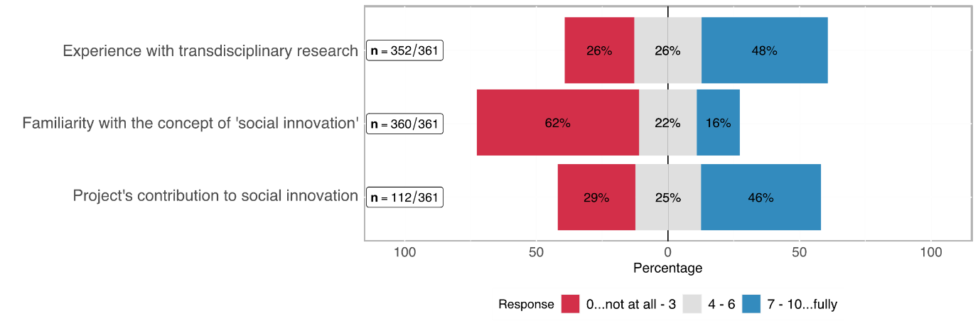



Table 4: Self-assessment in terms of transdisciplinary experience, familiarity with SI, project's contribution to SI

|  |  |  |  |  |  |  |
| --- | --- | --- | --- | --- | --- | --- |
| Rating | Transdisciplinary experience  (n = 352) | | Familiarity with SI  (n = 360) | | Project's contribution to SI  (n = 112) | |
| *0..lowest*  *10..highest* | abs | % | abs | % | abs | % |
| 0 | 19 | 5.26% | 116 | 32.22% | 5 | 4.46% |
| 1 | 17 | 4.71% | 36 | 10.00% | 3 | 2.68% |
| 2 | 26 | 7.20% | 33 | 9.17% | 12 | 10.71% |
| 3 | 31 | 8.59% | 37 | 10.28% | 13 | 11.61% |
| 4 | 21 | 5.82% | 25 | 6.94% | 7 | 6.25% |
| 5 | 37 | 10.25% | 37 | 10.28% | 13 | 11.61% |
| 6 | 32 | 8.86% | 17 | 4.72% | 8 | 7.14% |
| 7 | 58 | 16.07% | 19 | 5.28% | 17 | 15.18% |
| 8 | 40 | 11.08% | 20 | 5.56% | 22 | 19.64% |
| 9 | 27 | 7.48% | 6 | 1.67% | 6 | 5.36% |
| 10 | 44 | 12.19% | 14 | 3.89% | 6 | 5.36% |
| no response | *9* |  | *0* |  | *1* |  |

As regards the ***familiarity with SI***, 360 participants responded. 62 % of whom stated to be *not at all* to *barely* familiar with the idea of SI (3 and below on a 0-10 scale), roughly 22 % consider themselves as moderately familiar (4-6 on that scale), and 16 % as *familiar* to *highly familiar*. Figure 2 (second row) provides a visual overview on this distribution, while Table 5 (centre columns) details all the responses in each category separately.

This variable is particularly interesting when further analysing whether researchers from a scientific domain are more familiar with the concept than researchers from another scientific domain –Section 3.2.2 answers this question. Overall we can summarise that a rudimentary conceptual understanding of SI not (yet) common sense in the scientific world.

Out of the 113 *eligible*[[4]](#footnote-4) participants, i.e. those who believe to be at least moderately familiar with SI, 112 chose to answer the question regarding their ***project’s contribution to SI*** (see bottom row of Figure 2 above). Of those, 29 % stated that their project contributed little to nothing to SI, while 46 % stated that it was high to very high.

The third variable in the group of self-assessments is the *project’s contribution to SI*. An especially interesting scenario is when respondents show a low level of familiarity with SI but a high level of contribution to SI as it makes it necessary to verify whether the claim is true (based on outcome variables presented below) or whether respondents overestimated their project’s contribution.

### Respondents’ *experience with* *transdisciplinary research* and *age*

This sub-section follows up on the question, whether the respondents’ *age* had anything to do with their *experience with transdisciplinary research*. Figure 3 shows the distribution of the transdisciplinary experience on the x-axis (0..10 from lowest to highest), while the age groups are shown on the y-axis. Some variance is noticeable but a general trend is not visible. Even the younger age groups are spread across a low to a high degree of transdisciplinary experience.

The *Hypotheses* chapter (pp. 23) examines interesting potential correlations but, as a sneak preview, we can already say that this one is not among them, because the two variables “age” and “transdisciplinary experience” do not correlate strongly enough to be considered important factors contributing to SI.

Figure 3: Distribution of the transdisciplinary experience

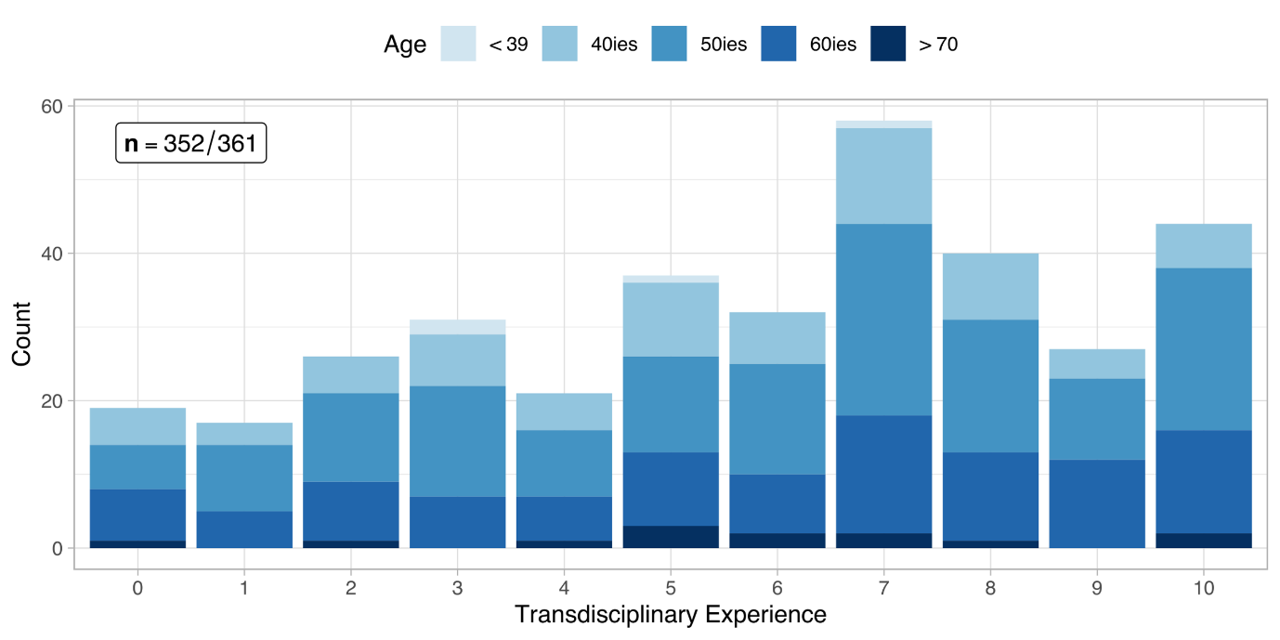

### Respondents’ *familiarity with social innovation* and *scientific domains*

SI is a relatively little-known concept among most of the survey respondents as described above. The question is, though, whether there is a difference between scientific domains when it comes to the familiarity of researchers with the concept of SI.

The distribution of participants across the three domains is balanced, each represents roughly one third of the overall number of participants (cf. Table 2). As Figure 4 and Table 5 show, the share of researchers from the Humanities and Social Sciences increases with each higher degree of *familiarity with SI* while the share of the other two domains dwindles in comparison.

This observation corresponds with our expectations and will further be examined in the hypothesis chapter in section 4.1.2 (pp. 26) of the chapter on hypotheses.

Figure 4: Distribution of the familiarity with social innovation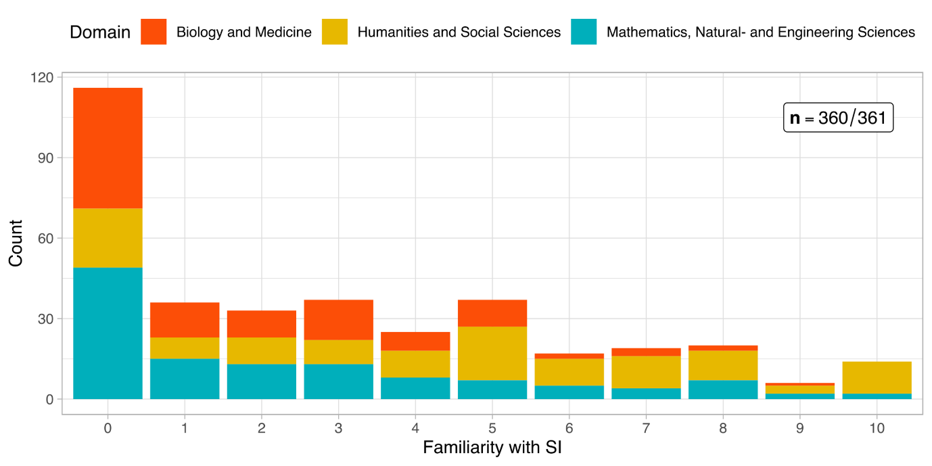

### Project’s contribution to SI (self-assessment)

Respondents were asked about their project’s contribution to SI as a control variable, firstly, to scrutinise the relationship between the self-assessment and model-driven SI-Index[[5]](#footnote-5), and secondly, to conclude if the self-assessment was generally overestimated. As the figure below and Table 5 show, there is no clear distribution across the offered rating spectrum.

Figure 5: Distribution of self-assessed SI-Contribution

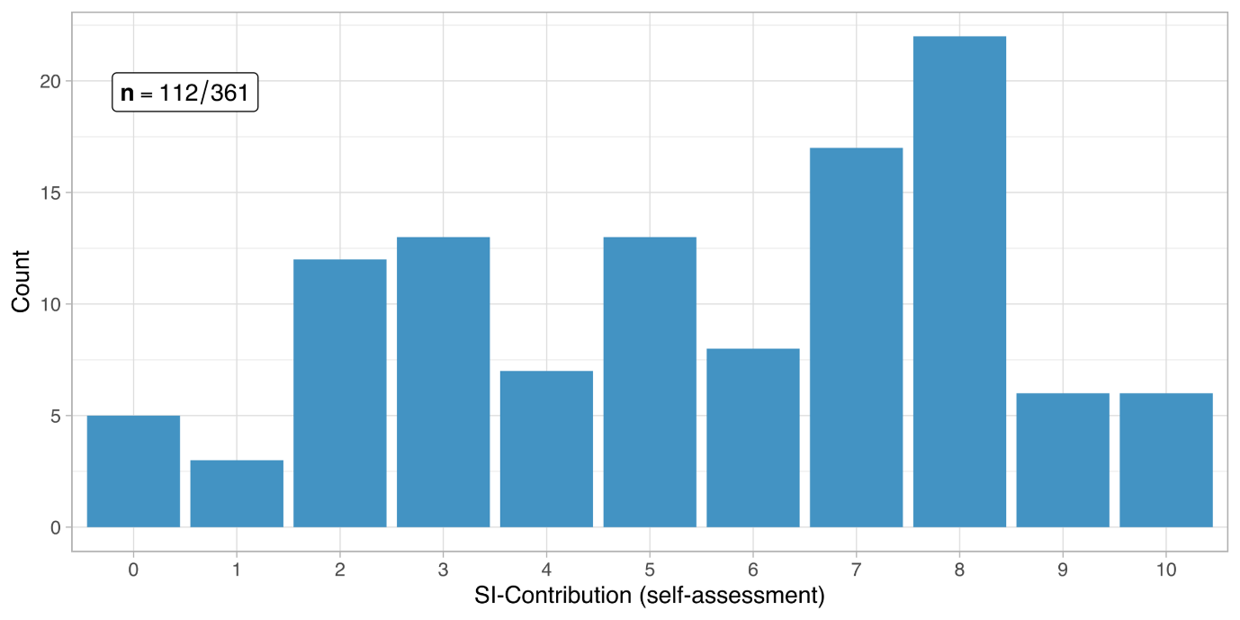

## Intention & Agency

### Motivation types

The type of motivation that drives academics to conduct research is important to understand the content orientation, the design, and the results of the study. The initial motivation types measured in this study consist of three main categories, namely, motivation to *better understand a natural, technical, economic, or social phenomenon* (basic academic motivation that drives research), to *directly address a natural, technical, economic, or social problem* (use-inspired research)*,* to *improve the human condition/welfare* (motivation to create impact outside of academia).

The basic academic motivation to better understand a natural, technical, economic or social phenomenon was strongly emphasised in the survey results (see Figure 6): 84 % of the survey respondents marked academic motivation greater or equal to 7 on a 0-10 scale, it has also one of the highest response ratios in the survey (only one responded did not reply to this question). This was followed by motivation to directly address a problem (64 % of the respondents noting equal to or higher levels than 7). Improving the human condition/welfare, i.e. the motivation closest associated with social innovation, namely to cause social impact outside of academia, was more balanced in comparison. 35 % of the respondents replied with levels equal to or smaller than 3 and 45 % with levels equal to or higher than 7 in terms of improving the human condition/welfare being one of the main motivations in their research project. For more detailed responses, refer to Table 6. We can conclude that the motivation portfolio of SNSF funded PIs is overall not one-dimensionally oriented towards only the basic scientific motivation of better understanding a phenomenon, but includes also a remarkable share of problem-orientation and use-inspiration including a quite strongly expressed notion of doing good for human condition/welfare. A high proportion of SNSF-funded projects have thus the motivational potential to more directly contribute to SI through their research.

Figure 6: Distribution of different motivation types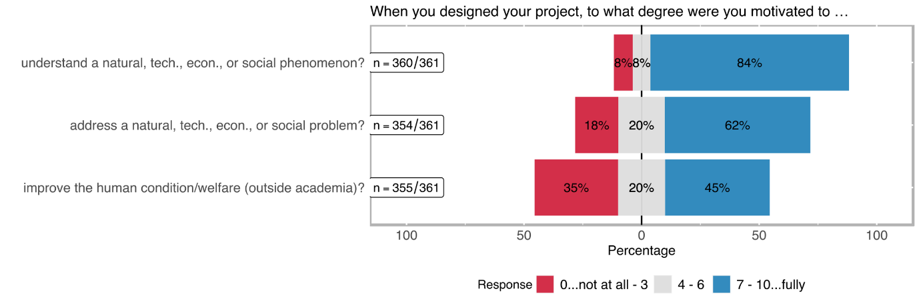

Table 6: Distribution of different motivation types

|  |  |  |  |  |  |  |
| --- | --- | --- | --- | --- | --- | --- |
| When you designed your project, to what degree were you motivated to… | | | | | | |
|  | **better understand a natural, technical, economic, or social phenomenon?** | | **directly address a natural, technical, economic, or social problem?** | | **improve the human condition/welfare (outside academia)?** | |
| **Rating** | **abs** | **%** | **abs** | **%** | **abs** | **%** |
| *0..lowest*  *10..highest* | 14 | 3.89% | 23 | 6.50% | 47 | 13.24% |
| 0 | 1 | 0.28% | 7 | 1.98% | 23 | 6.48% |
| 1 | 8 | 2.22% | 25 | 7.06% | 30 | 8.45% |
| 2 | 6 | 1.67% | 10 | 2.82% | 26 | 7.32% |
| 3 | 12 | 3.33% | 16 | 4.52% | 16 | 4.51% |
| 4 | 9 | 2.50% | 28 | 7.91% | 43 | 12.11% |
| 5 | 6 | 1.67% | 26 | 7.34% | 12 | 3.38% |
| 6 | 17 | 4.72% | 36 | 10.17% | 41 | 11.55% |
| 7 | 42 | 11.67% | 56 | 15.82% | 53 | 14.93% |
| 8 | 38 | 10.56% | 28 | 7.91% | 15 | 4.23% |
| 9 | 207 | 57.50% | 99 | 27.97% | 49 | 13.80% |
| 10 | 14 | 3.89% | 23 | 6.50% | 47 | 13.24% |
| *no response* | *1* |  | *7* |  | *6* |  |

### Intention to benefit the non-academic world

Approximately 37 % of the respondents note that their projects were not specifically designed to benefit a social group (cf. Figure 7 and Table 7). Almost exactly the same number of respondents indicated that this type of deliberative design was only present to a minor extent in their research project. 25 % of the respondents noted that their projects were specifically designed to generate a benefit for the general population or a specific social group.

Figure 7: Distribution of impulses from the non-academic world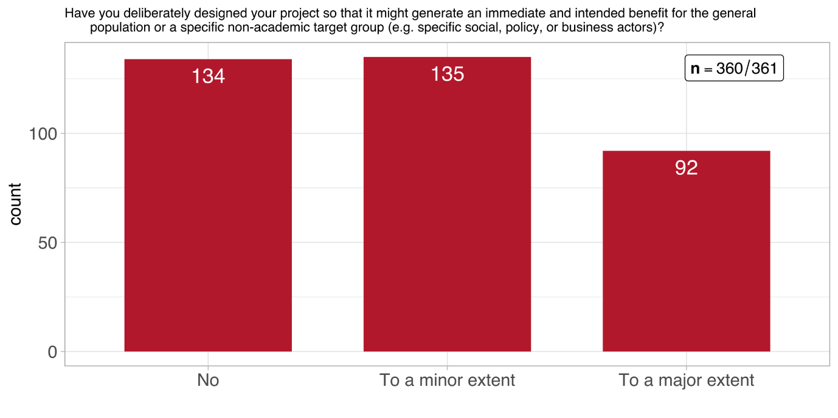

Table 7: Distribution of impulses from the non-academic world (n = 360)

|  |  |  |
| --- | --- | --- |
| response | abs | % |
| no | 133 | 36.94% |
| to a minor extent | 135 | 37.50% |
| to a large extent | 92 | 25.56% |
| *no response* | *1* |  |

Most of the impulses from the non-academic world that motivated SNSF PIs to start their projects referenced specific health/medical problems (33%), followed by specific societal problems (26%) or specific technical problems (19%) (see Figure 8 and Table 8). To tackle a specific economic problem was least referred as an impulse by PIs conducting SNSF projects (8%).

Figure 8: Distribution of impulses from the non-academic world (multiple choice)

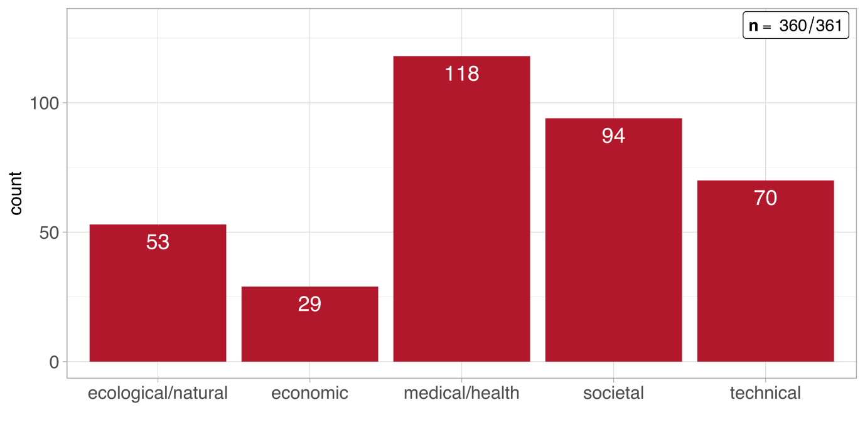

Table 8: Distribution of impulses from the non-academic world (multiple choice)

|  |  |  |
| --- | --- | --- |
| response | abs | % |
| a specific societal problem | 94 | 26.04% |
| a specific economic problem | 29 | 8.03% |
| a specific ecological/natural problem | 53 | 14.68% |
| a specific health/medical problem | 118 | 32.69% |
| a specific technical problem | 70 | 19.39% |
| Other | 62 | 17.17% |

## Actors & Networks

### Level and nature of inter-/transdisciplinary involvement

Interdisciplinary cooperation is common among the SNSF funded projects. 41 % of the respondents note that the involvement of academicians from other disciplines was quite central to their specific project (see Figure 9). In total 78 % of the projects were carried out with the collaboration of researchers from other disciplines (see Table 9). Transdisciplinary involvement has been measured via different categories which indicate the inclusion of different types of societal actors and groups in the research process. Although by far not as central as the interdisciplinary cooperation, different types of transdisciplinary engagement constitute a noteworthy part of the research projects. Transdisciplinary involvement types such as involvement of citizens, involvement of policy makers/public administration, involvement of institutions providing welfare or education or involvement of companies, yield somewhat similar distributions among the projects of the survey respondents (22% - 27% of involvement rated above 3; 0 is the minimum and 10 the maximum). An exception to this rather equal distribution is media, which was quite often involved in SNSF projects, but rarely centrally. Thus we assume that media was mainly involved in terms of pure dissemination purposes.

Figure 9: Level of interdisciplinary and transdisciplinary involvement

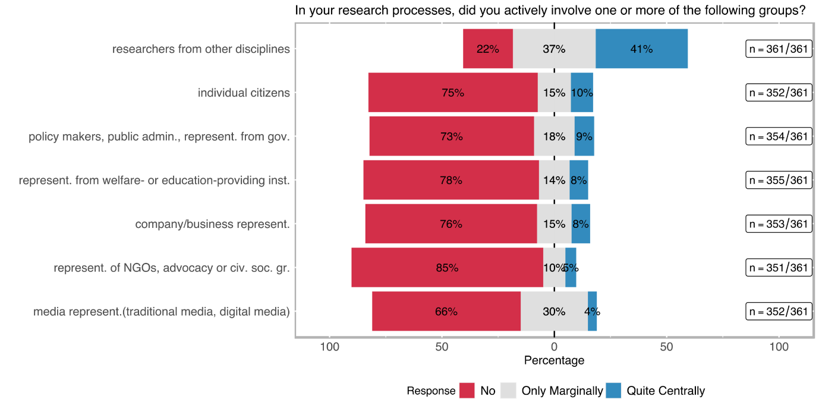

Table 9: Level of interdisciplinary and transdisciplinary involvement

|  |  |  |  |  |  |  |
| --- | --- | --- | --- | --- | --- | --- |
| Involved stakeholder group | no | | only marginally | | quite centrally | |
|  | **abs** | **%** | **abs** | **%** | **abs** | **%** |
| ACADEMIC |  | | | | | |
| researchers from other disciplines (n=361) | 80 | 22.16% | 133 | 36.84% | 148 | 41.00% |
| NON-ACADEMIC |  | | | | | |
| company/business representatives (incl. farmers) (n=352) | 269 | 76.42% | 54 | 15.34% | 29 | 8.24% |
| representatives of NGOs, advocacy or other civil society groups (n=354) | 302 | 85.31% | 35 | 9.89% | 17 | 4.80% |
| policy makers, public administrations, representatives from governmental agencies (n=355) | 260 | 73.24% | 64 | 18.03% | 31 | 8.73% |
| individual citizens (e. g. as beneficiaries, customers, or concerned persons) (n=353) | 266 | 75.35% | 52 | 14.73% | 35 | 9.92% |
| media representatives (traditional media, digital media (e. g. bloggers), journalists, community-led media, etc.) (n=351) | 232 | 66.10% | 105 | 29.91% | 14 | 3.99% |
| representatives from welfare- or education-providing institutions (such as schools, kindergartens, hospitals, or care centres) (n=352) | 275 | 78.13% | 48 | 13.64% | 29 | 8.24% |

Although the centrality of involvement indicates to which extent specific groups were involved in the project, in the case of transdisciplinarity the role of participating social groups is often overlooked. Motivated by our literature research we have decided that the *nature of involvement* (indicated with the labels; *consultative, contributory, collaboratively, co-created*) carries at least as much information as the centrality of the involvement about the occurrence of SI-related aspects.

Figure 10 and Table 10 show that transdisciplinary involvement is mostly *consultative* or *contributory*. Collaborative transdisciplinary involvement is more likely employed when welfare/education institutions or company/business experts are involved in the project (20 % and 22 % respectively). A co-creation approach is rare being followed: the highest co-creative involvement belongs to projects that include individual citizens (10 %).

Participatory research designs often aim at mobilising specific social groups’ potential to create actions and affect change through direct collaboration with affected stakeholders[[6]](#footnote-6). Transdisciplinary involvement of citizens, therefore, is often associated with SI-related outcomes. Therefore, [H] we are expecting more central engagement of the individual citizens with higher levels of SI-Familiarity.

Figure 10: Nature of transdisciplinary involvement per stakeholder group 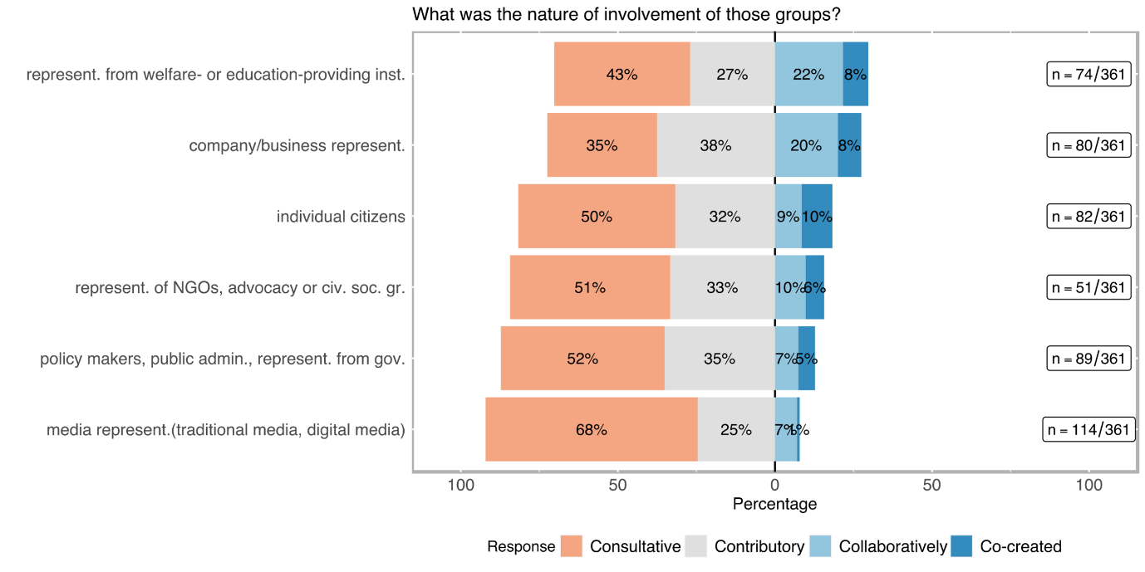

Table 10: Nature of transdisciplinary involvement per stakeholder group

|  |  |  |  |  |  |  |  |  |  |  |
| --- | --- | --- | --- | --- | --- | --- | --- | --- | --- | --- |
| Involved stakeholder group | consultative[[7]](#footnote-7) | | contributory[[8]](#footnote-8) | | | collaborative[[9]](#footnote-9) | | | co-created[[10]](#footnote-10) | |
|  | **abs** | **%** | **abs** | | **%** | **abs** | **%** | | **abs** | **%** |
| ACADEMIC |  | | |  | | | |  | | |
| researchers from other disciplines (n=278) | 37 | 13.31% | 57 | | 20.50% | 109 | 39.21% | | 75 | 26.98% |
| NON-ACADEMIC |  | | |  | | | |  | | |
| company/business representatives (incl. farmers) (n=80) | 28 | 35.00% | 30 | | 37.50% | 16 | 20.00% | | 6 | 7.50% |
| representatives of NGOs, advocacy or other civil society groups (n=51) | 26 | 50.98% | 17 | | 33.33% | 5 | 9.80% | | 3 | 5.88% |
| policy makers, public administrations, representatives from governmental agencies (n=94) | 49 | 52.13% | 33 | | 35.11% | 7 | 7.45% | | 5 | 5.32% |
| individual citizens (e. g. as beneficiaries, customers, or concerned persons) (n=82) | 41 | 50.00% | 26 | | 31.71% | 7 | 8.54% | | 8 | 9.76% |
| media representatives (traditional media, digital media (e. g. bloggers), journalists, community-led media, etc.) (n=114) | 77 | 67.54% | 28 | | 24.56% | 8 | 7.02% | | 1 | 0.88% |
| representatives from welfare- or education-providing institutions (such as schools, kindergartens, hospitals, or care centres) (n=74) | 32 | 43.24% | 20 | | 27.03% | 16 | 21.62% | | 6 | 8.11% |

### Goals with regard to target groups

Figure 11: Distribution of target group goals

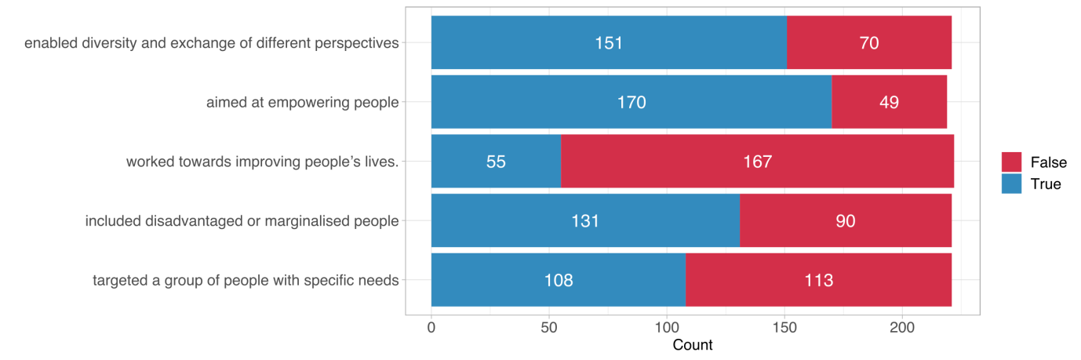

Envisioned social goals of the project can be important indicators of social innovation. Several true/false statements concerning foreseen social impact or social inclusion goals were raised to measure further aspects of transdisciplinarity. *Aim to empower targeted or included social groups* was the most frequently selected category (170 times) followed by *enabling diversity and exchange of different perspectives* (151 times). The category *the project worked towards improving people’s lives* was the least frequent selected category (55 times).

Table 11: Distribution of target group goals

|  |  |  |  |  |
| --- | --- | --- | --- | --- |
| Goal | no |  | yes |  |
|  | **abs** | **%** | **abs** | **%** |
| targeted a group of people with specific social needs (n= 221) | 151 | 68.33% | 70 | 31.67% |
| included socially disadvantaged or marginalised people (n=219) | 170 | 77.63% | 49 | 22.37% |
| worked towards improving people’s lives (n=222) | 55 | 24.77% | 167 | 75.23% |
| aimed at empowering people (in general or specific groups) (n=221) | 131 | 59.28% | 90 | 40.72% |
| enabled diversity and exchange of different perspectives (n=221) | 108 | 48.87% | 113 | 51.13% |

## Regulatory Framework

### Open Science concepts

A critical part of carrying out the social goals envisioned in the research process is to ensure project results are available for a broader audience. Therefore, open science practices are a potentially first step to reach – at least intentionally - beyond the realms of academic world (see Figure 12). Survey results show that *open access publication* (326 times, ~ 90 % of the survey respondents; see Table 12) have become standard among the funded SNSF projects. The majority of SNSF funded projects employs also *open access data* (234 times). Other open science categories are employed by minority shares of SNSF funded projects. Although their use varies between 25% (open/shared infrastructure) and 38% (open peer revies), the results indicate a remarkable ongoing shift towards an open science culture.

Following the dependence of social impact on the accessibility of results, [H] we assume that the number of open access practices tends to rise with higher levels of transdisciplinary experience.

Figure 12: Open science concepts in research projects

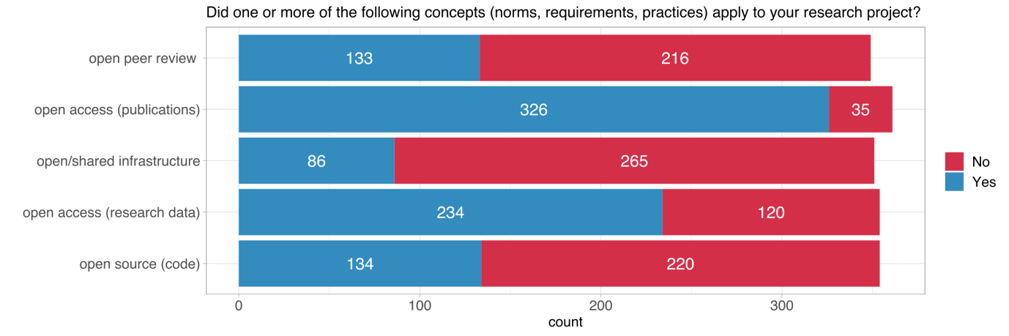

Table 12: Open science concepts in research projects

|  |  |  |  |  |
| --- | --- | --- | --- | --- |
| Open science dimension | no |  | yes |  |
|  | **abs** | **%** | **abs** | **%** |
| open access (publications) (n=361) | 35 | 9.70% | 326 | 90.30% |
| open access (research data) (n=354) | 120 | 33.90% | 234 | 66.10% |
| open source (code) (n=354) | 220 | 62.15% | 134 | 37.85% |
| open/shared infrastructure (n=351) | 265 | 75.50% | 86 | 24.50% |
| open peer review (e. g. participation of a wider community or post-publication commenting) (n=349) | 216 | 61.89% | 133 | 38.11% |

### Explicit consideration of gender dimension

The respondent were asked if they consider the gender dimension in their projects. This question refers to the research design and research content and not to gender equality in research and research funding per se.[[11]](#footnote-11) Gender-sensitive research incorporates the gender dimension throughout the entire research process. Connections and interactions of gender with central analytical questions and categories as well as potential discrimination structures are perceived, reflected and taken into account in the research process. Gender-blind research is research without reflection on gender.

The gender dimension is disregarded because of the - sometimes incorrect - assumption that it is irrelevant to the research questions and analyses and/or that the research has no effect on people[[12]](#footnote-12). This can potentially lead to a gender bias. Gender-sensitive research thus poses the question, within the framework of research design, of how gender is integrated into scientific knowledge and whether the category of gender is systematically taken into account in the development of knowledge.

We lack benchmarks on the inclusion of the gender dimension in research projects, but could identify that overall the share of SNSF funded projects which include the gender dimension is around 23% (see Figure 13).

Figure 13: Distribution of the explicit gender dimension consideration among the projects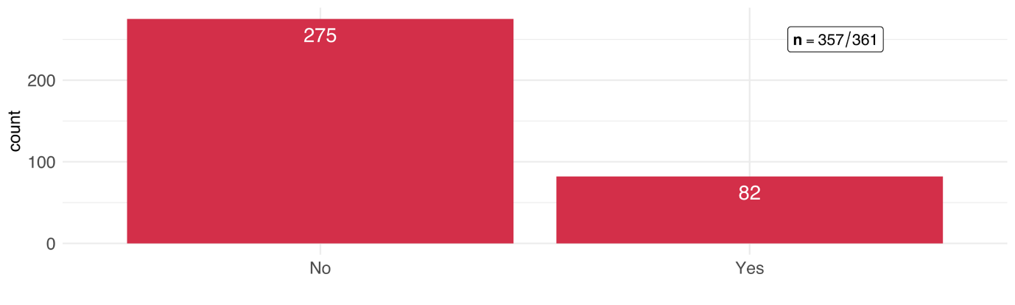

### Intent to support policymaking

Figure 14: Distribution of the explicit intent to support evidence-based decision-making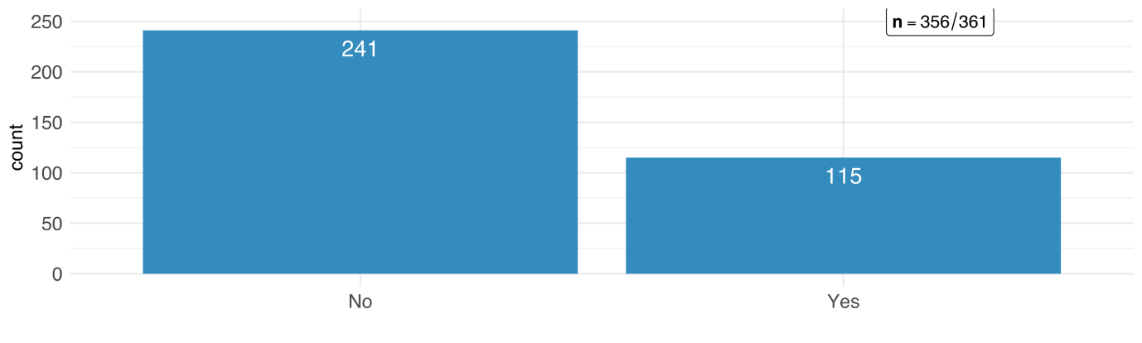

We have also asked the PIs of SNSF funded projects if their project aims at supporting evidence-based decision-making of policy-makers to indicate a proximity to the political relevance of the results in whatever political field or arena. For as many as one third of the respondents, this is true in their respective projects (see Figure 14).

## Outcome Orientation

### Direct contributions to target group(s)

Research projects funded by SNSF rarely contribute directly to new services, products, or processes. Although the majority of respondents marked 3 or lower on a 0-10 scale for all of the specific categories (see Figure 15), ~ 40 % of the respondents noted that their project results somewhat directly contributed to new/better products and services for the general population. 18 % of respondents even stated to have strongly contributed to benefit the general population (cf. Table 13).

Our definition of SI encompasses outcome-orientation, both tangible and non-tangible. In other words, if the intention to achieve impact is missing, then a constitutive element that characterises social innovation is missing too. This does not mean that the project may not have contributed to social innovation in the end. However, from a definitional point of view, it does not correspond to the intentional understanding of a social innovation. Although direct outcomes are often rare among the scientific projects, we assume that the transdisciplinary inclusion of a societal group increases the chances of a direct outcome for that specific group (for more on this see section 4.1.5).

Figure 15: Direct contribution to target group(s)

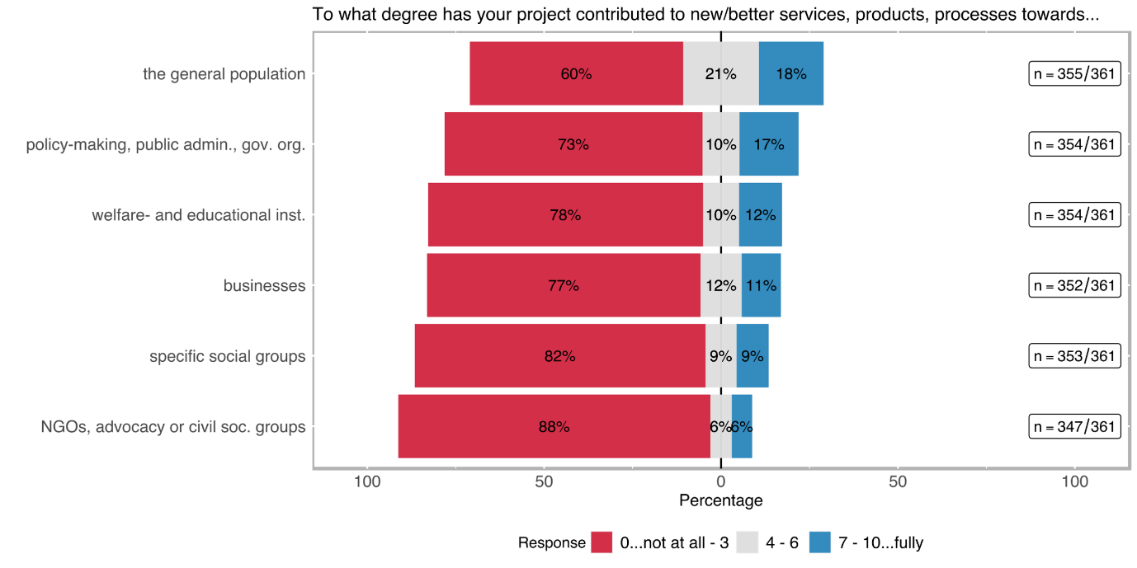

Table 13: Direct contribution to target group(s)

|  |  |  |  |  |  |  |  |  |  |  |  |  |  |  |
| --- | --- | --- | --- | --- | --- | --- | --- | --- | --- | --- | --- | --- | --- | --- |
|  | the general population (n=355) | | businesses (n=352) | | specific social groups[[13]](#footnote-13) (n=353) | | welfare- and education-providing institutions[[14]](#footnote-14) (n=354) | | NGOs, advocacy or other civil society groups (n=347) | | policy-making, public administration, governmental agencies (n=354) | | academia (n=357) | |
| response | abs | % | abs | % | abs | % | abs | % | abs | % | abs | % | abs | % |
| 0 | 116 | 32.68 | 177 | 50.28 | 223 | 63.17 | 200 | 56.50 | 241 | 69.45 | 185 | 52.26 | 29 | 8.12 |
| 1 | 26 | 7.32 | 32 | 9.09 | 30 | 8.50 | 32 | 9.04 | 27 | 7.78 | 26 | 7.34 | 3 | 0.84 |
| 2 | 39 | 10.99 | 36 | 10.23 | 24 | 6.80 | 21 | 5.93 | 22 | 6.34 | 25 | 7.06 | 8 | 2.24 |
| 3 | 33 | 9.30 | 27 | 7.67 | 13 | 3.68 | 22 | 6.21 | 16 | 4.61 | 22 | 6.21 | 8 | 2.24 |
| 4 | 15 | 4.23 | 13 | 3.69 | 8 | 2.27 | 13 | 3.67 | 7 | 2.02 | 11 | 3.11 | 10 | 2.80 |
| 5 | 40 | 11.27 | 24 | 6.82 | 13 | 3.68 | 12 | 3.39 | 10 | 2.88 | 20 | 5.65 | 27 | 7.56 |
| 6 | 21 | 5.92 | 4 | 1.14 | 10 | 2.83 | 11 | 3.11 | 4 | 1.15 | 6 | 1.69 | 16 | 4.48 |
| 7 | 21 | 5.92 | 9 | 2.56 | 11 | 3.12 | 14 | 3.95 | 9 | 2.59 | 22 | 6.21 | 46 | 12.89 |
| 8 | 22 | 6.20 | 11 | 3.13 | 10 | 2.83 | 14 | 3.95 | 3 | 0.86 | 19 | 5.37 | 59 | 16.53 |
| 9 | 5 | 1.41 | 6 | 1.70 | 4 | 1.13 | 6 | 1.69 | 3 | 0.86 | 5 | 1.41 | 41 | 11.48 |
| 10 | 17 | 4.79 | 13 | 3.69 | 7 | 1.98 | 9 | 2.54 | 5 | 1.44 | 13 | 3.67 | 110 | 30.81 |

### Intended Effects

In the online survey, we inquired about intended changes to investigate potential project outcomes, both in the long and short term. We differentiated four categories of effects: (i) improving understanding as most generic effect of scientific research; (ii) raising awareness of an issue; (iii) changing attitude, which has a normative change connotation, and (iv) changing behaviour, which has an action-oriented connotation.

*Improving the understanding* as well as *raising awareness* in the general population is by far the most frequently selected category (79 and 50 times respectively; cf. Figure 16 and Table 14). Other arguably stronger types of changes (attitude and behaviour) are occurring relatively less frequent among all of the defined societal actor categories. However, 31 respondents note the intended effect (or one of the intended effects) of their research project was a behavioural change among policymakers and/or public administration.

Figure 16: Distribution of intended changeChart, bar chart

Description automatically generated

Table 14: Distribution of intended change

|  |  |  |  |  |  |  |  |  |  |  |
| --- | --- | --- | --- | --- | --- | --- | --- | --- | --- | --- |
|  | Changing … | | | | | | | | | |
| Target audience | **under­standing** | | **awareness** | | **attitude** | | **behaviour** | | **other** | |
|  | **abs** | **%** | **abs** | **%** | **abs** | **%** | **abs** | **%** | **abs** | **%** |
| the general population (n=170) | 79 | 46.47% | 50 | 29.41% | 10 | 5.88% | 15 | 8.82% | 16 | 9.41% |
| businesses (n=100) | 29 | 29.00% | 29 | 29.00% | 12 | 12.00% | 18 | 18.00% | 12 | 12.00% |
| specific social groups (n=73) | 22 | 30.14% | 19 | 26.03% | 12 | 16.44% | 15 | 20.55% | 5 | 6.85% |
| welfare- and education-providing institutions (n=93) | 35 | 37.63% | 24 | 25.81% | 10 | 10.75% | 17 | 18.28% | 7 | 7.53% |
| NGOs, advocacy or other civil society groups (n=53) | 13 | 24.53% | 20 | 37.74% | 5 | 9.43% | 12 | 22.64% | 3 | 5.66% |
| policy-making, public administration, governmental agencies (n=117) | 33 | 28.21% | 33 | 28.21% | 15 | 12.82% | 31 | 26.50% | 5 | 4.27% |
| academia (n=312) | 219 | 70.19% | 32 | 10.26% | 21 | 6.73% | 28 | 8.97% | 12 | 3.85% |

### Uptake by decision-makers

The uptake of the project results by decision-makers is one of the indicators of project outcomes. The survey was designed to explore this aspect using two different questions, which were mainly aimed to measure how far the project results have been adopted by the authorities and what was the nature of the uptake.

Figure 17: Uptake of project results by policy-makers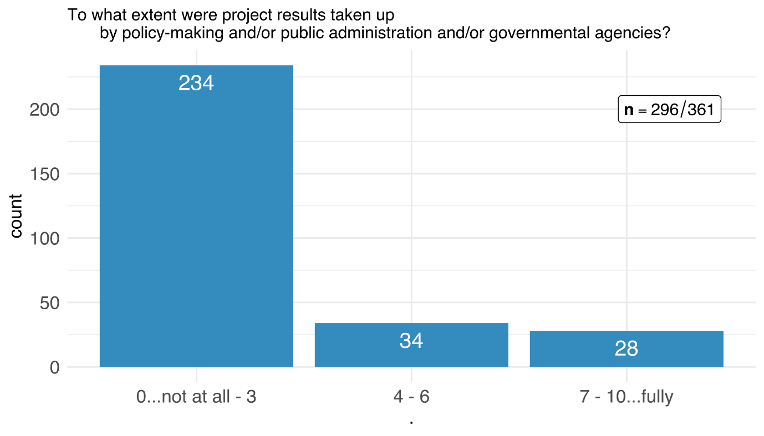

Approximately 20 % of the respondents rated the *uptake of the project results by decision-makers* moderate to high (see Table 15). However, an overwhelming majority of the respondents reported that there was little to no uptake of the project results by policy-makers, public administration or governmental agencies

Table 15: Uptake of project results by policy-makers

|  |  |  |
| --- | --- | --- |
|  | adopted by policy (n=296) | |
| response | abs | % |
| 0 | 153 | 51.69% |
| 1 | 22 | 7.43% |
| 2 | 42 | 14.19% |
| 3 | 17 | 5.74% |
| 4 | 9 | 3.04% |
| 5 | 15 | 5.07% |
| 6 | 10 | 3.38% |
| 7 | 9 | 3.04% |
| 8 | 12 | 4.05% |
| 9 | 2 | 0.68% |
| 10 | 5 | 1.69% |
| *not applicable* | *57* |  |
| *no response* | *8* |  |

Figure 18: Kind of uptake of project results by policy-makers Chart, bar chart

Description automatically generated

The nature of the policy uptake indicates what kind of a change the uptake by policymakers and public administration caused. Nine respondents claim that the results of their projects changed/influenced laws and regulations, 22 respondents note that the results changed specific agenda-settings and 31 reported about changed policies (i.e. changes in policy measures) (see Figure 18). This means that 17% of the SNSF funded projects had an impact on policy or public administration, mostly in the way how policies or policy measures are designed and implemented.

We assume that [H] the nature of involvement of policymakers has a statistically significant relation nature of policy uptake.

Table 16: Kind of uptake of project results by policy-makers

|  |  |  |
| --- | --- | --- |
|  | Nature of uptake by policy-makers (n=62) | |
| response | abs | % |
| Changed policy (measures) | 31 | 34.83% |
| Changed agenda-setting | 22 | 24.72% |
| Changed regulation or law | 9 | 10.11% |
| *Other* | *27* |  |

### Impact statements

Figure 19: Impact statements – change affected through the funded research project

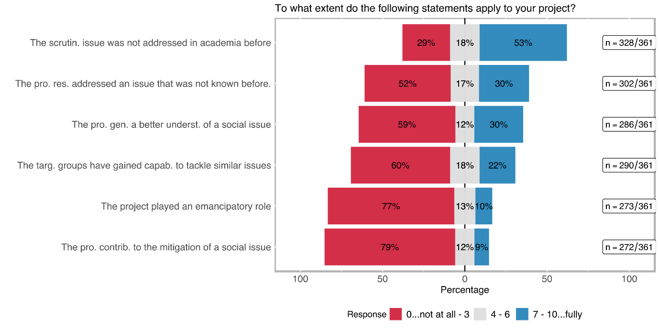

The last question in the outcome orientation section of the survey focused on impact statements and how the impacts of the scrutinised SNSF projects corresponded to these statements. The statements are chosen to address SI-relevant aspects directly. The academic dimension was by far the highest-rated statement among the survey respondents (see Figure 19), 53 % of the respondents rated the statement *the scrutinised issue was not (widely) addressed in academia before* 7 or higher on a scale from 0 to 10 (cf. Table 17). This result is followed by a similar statement *the project results addressed an issue that was not (widely) known before* which was specifically directed to the novelty of the issue for the public, 30 % of the respondents rated this statement 7 or higher. The statement *the project generated a deeper/better understanding of the social issue* was rated similarly by the respondents. It is striking that as many as 10% resp. 9% of the SNSF funded projects contributed to emancipatory impact or the mitigation of a social issue.

Table 17: Impact statements – change affected through the funded research project

|  |  |  |  |  |  |  |  |  |  |  |  |  |
| --- | --- | --- | --- | --- | --- | --- | --- | --- | --- | --- | --- | --- |
|  | capacity to tackle similar issues (n=290) | | Emancipa­tion (n=273) | | deeper/ better understan­ding of a specific social issue (n=286) | | mitigation of a social issue (n=272) | | issue not (widely) known in the society (n=302) | | issue not (widely) addressed in academia (n=328) | |
| response | **abs** | **%** | **abs** | **%** | **abs** | **%** | **abs** | **%** | **abs** | **%** | **abs** | **%** |
| 0 | 105 | 36.21 | 142 | 52.01 | 117 | 40.91 | 155 | 56.99 | 102 | 33.77 | 62 | 18.90 |
| 1 | 22 | 7.59 | 22 | 8.06 | 22 | 7.69 | 28 | 10.29 | 17 | 5.63 | 10 | 3.05 |
| 2 | 26 | 8.97 | 26 | 9.52 | 10 | 3.50 | 17 | 6.25 | 13 | 4.30 | 8 | 2.44 |
| 3 | 22 | 7.5% | 20 | 7.33 | 19 | 6.64 | 16 | 5.88 | 26 | 8.61 | 15 | 4.57 |
| 4 | 18 | 6.21 | 11 | 4.03 | 12 | 4.20 | 8 | 2.94 | 17 | 5.63 | 16 | 4.88 |
| 5 | 19 | 6.55 | 15 | 5.49 | 9 | 3.15 | 16 | 5.88 | 19 | 6.29 | 25 | 7.62 |
| 6 | 15 | 5.17 | 9 | 3.30 | 12 | 4.20 | 8 | 2.94 | 16 | 5.30 | 18 | 5.49 |
| 7 | 24 | 8.28 | 10 | 3.66 | 25 | 8.74 | 6 | 2.21 | 23 | 7.62 | 39 | 11.89 |
| 8 | 18 | 6.21 | 6 | 2.20 | 23 | 8.04 | 9 | 3.31 | 24 | 7.95 | 54 | 16.46 |
| 9 | 9 | 3.10 | 6 | 2.20 | 17 | 5.94 | 4 | 1.47 | 15 | 4.97 | 27 | 8.23 |
| 10 | 12 | 4.14 | 6 | 2.20 | 20 | 6.99 | 5 | 1.84 | 30 | 9.93 | 54 | 16.46 |

## Dissemination and Exploitation

### Dissemination Channels

Figure 20: Distribution of dissemination channels

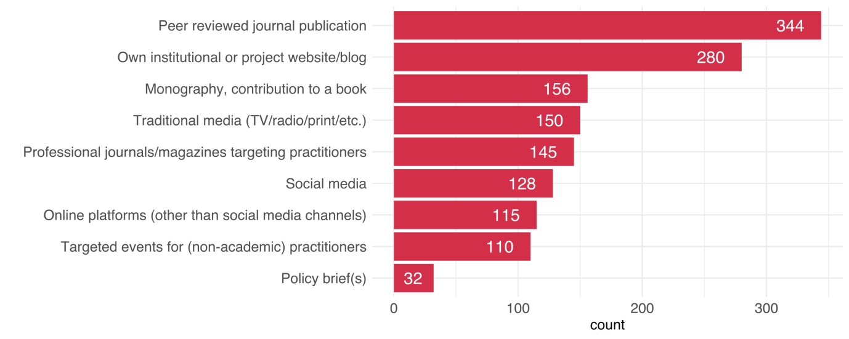

How a project disseminates its results also delivers important information about the project’s character and intention. Some of the options like peer-reviewed journal publications or the dissemination on the organisations’ own website have unsurprisingly high numbers (see Figure 20). In general, however, a wide range of dissemination channels was used, including books, traditional and social media, and articles in professional journals for practitioners etc. Policy briefs were rated lowest but 110 projects stated to have organised events for non-academic practitioners (see Table 18).

Table 18: Dissemination channels

|  |  |  |  |  |
| --- | --- | --- | --- | --- |
| Dissemination channel | no | | yes | |
|  | **abs** | **%** | **abs** | **%** |
| Peer reviewed journal publication (n=358) | 14 | 3.91% | 344 | 96.09% |
| Monography, contribution to a book (n=342) | 186 | 54.39% | 156 | 45.61% |
| Conference proceeding (n=356) | 52 | 14.61% | 304 | 85.39% |
| Policy brief(s) (n=333) | 301 | 90.39% | 32 | 9.61% |
| Traditional media (TV/radio/print/etc.) (n=346) | 196 | 56.65% | 150 | 43.35% |
| Professional journals/magazines targeting practitioners (n=343) | 198 | 57.73% | 145 | 42.27% |
| Own institutional or project website/blog (n=354) | 74 | 20.90% | 280 | 79.10% |
| Social media (n=347) | 219 | 63.11% | 128 | 36.89% |
| Online platforms (other than social media and project website/blog; e. g. data or code sharing, citizen science platforms) (n=343) | 228 | 66.47% | 115 | 33.53% |
| (You providing) consultancy (paid or unpaid) (n=342) | 226 | 66.08% | 116 | 33.92% |
| Targeted events for (non-academic) practitioners (n=343) | 233 | 67.93% | 110 | 32.07% |
| General events for a non-academic public (other than practitioners) (n=343) | 207 | 60.35% | 136 | 39.65% |

### Scalability

Figure 21: Type of scalability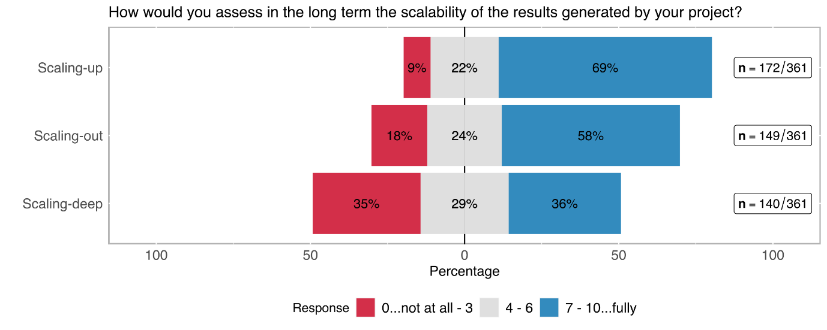

The scalability of the generated solutions to be applied in different contexts is another important goal in SI. 69 % of the respondents noted that the solutions generated throughout the project potentially have a high capability to be scaled up (cf. Figure 21 and Table 19), i.e. to achieve a higher impact if further used. Also the potential for scaling-out to different geographic areas was highly rated. This is hardly surprising, because most scientific research is not regionally limited but strives of universal knowledge and insights. Interestingly, 36% of the respondents also think that the project results can potentially also have a transformative impact in the sense of changing cultural and social values (scalling-deep).

Table 19: Type of scalability

|  |  |  |  |  |  |  |
| --- | --- | --- | --- | --- | --- | --- |
|  | Scaling-up (to achieve a higher impact) (n=172) | | Scaling-out (to different geographic areas) (n=149) | | Scaling-deep (by changing cultural and social values and practices) (n=140) | |
| response | abs | % | abs | % | abs | % |
| 0 | 3 | 1.74% | 11 | 7.38% | 17 | 12.14% |
| 1 | 4 | 2.33% | 6 | 4.03% | 12 | 8.57% |
| 2 | 2 | 1.16% | 7 | 4.70% | 10 | 7.14% |
| 3 | 6 | 3.49% | 3 | 2.01% | 10 | 7.14% |
| 4 | 6 | 3.49% | 5 | 3.36% | 13 | 9.29% |
| 5 | 21 | 12.21% | 25 | 16.78% | 17 | 12.14% |
| 6 | 11 | 6.40% | 6 | 4.03% | 10 | 7.14% |
| 7 | 36 | 20.93% | 24 | 16.11% | 16 | 11.43% |
| 8 | 38 | 22.09% | 33 | 22.15% | 15 | 10.71% |
| 9 | 10 | 5.81% | 5 | 3.36% | 5 | 3.57% |
| 10 | 35 | 20.35% | 24 | 16.11% | 15 | 10.71% |

# Hypotheses

The main focus of this study is to gain insights into the nature of SI in SNSF-funded research. *Hypothesis testing* is an integral part of the study which started with a set of assumptions derived from desk research. Those assumptions were to be tested via an online survey that targets principal investigators of SNSF-funded projects. The primary challenges were creating an adequate questionnaire to address our assumptions appropriately and especially turning those assumptions into scientifically testable hypotheses.

The current chapter is dedicated to presenting the most important findings of the hypotheses testing. To make it easier for readers, this chapter follows the same order as the previous chapter which described the survey results.

We would like to emphasise that the number of hypotheses testing far surpasses the results presented below and that we have chosen only the most relevant and interesting cases. To further save space, we did not explicitly name the null hypothesis H0 in cases like correlation test whereas the alternative hypothesis was already accepted at beginning and the exploration of the relationship between variables was the main issue.

### Transdisciplinary experience & motivation to affect change outside of academia

As introduced in section 3.2 (p. 1), almost 50 % of respondents rated their *transdisciplinary experience* as high (*7 and above* on a 0-10 scale). The relationship between a transdisciplinary approach and SI research is often discussed in SI literature. A high number of authors consider *transdisciplinarity* a necessity for SI, others go as far as to use *transdisciplinary* and *SI research* synonymously. However, causal explanations in the other direction can be found as well. For instance, Moulaert et al.[[15]](#footnote-15) understand SI as a driver of transdisciplinary research in that SI theory focuses on the nature of societal evolution. How its structures are being modified or its ethical norms revisited, or *vertical movements* in the society, like collective action, public uprising, or spontaneous/bottom-up organisation are all central concerns. Research focussing on SI consequently offers ample opportunities to apply transdisciplinary methods.

We do not consider the use of transdisciplinarity approaches in a research project as a precondition for its contribution to SI, but recognise that concerns that are central to SI are often central to transdisciplinary research as well. Thus it is more likely for researchers who employ transdisciplinary practices to contribute to societal impacts, compared to researchers with little or no transdisciplinary experience. We assume that

* H1: the *transdisciplinary experience* of the interviewed researchers correlates with
  1. the *motivation to address a problem outside of academia*, and
  2. the *motivation to improve human condition/welfare*.

Figure 22: Relation between transdisciplinary experience and the motivation to affect change outside academia

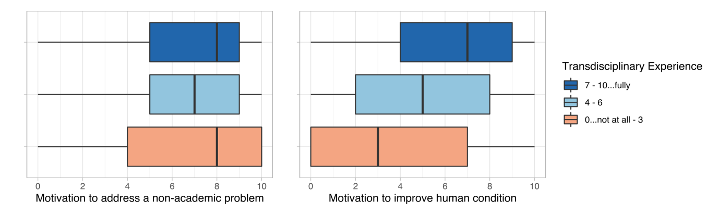

The purpose of survey questions related to the *motivation to* *directly address natural, technical, economic, or social problems* and the *motivation* *to improve the human condition/welfare*[[16]](#footnote-16) is to gauge the motivation to create impacts outside of academia.

The analysis of the relation between *transdisciplinary experience* and *the motivation to address a (non-academic) problem* (see Figure 20) does not yield a statistically significant correlation (correlation coefficient rho[[17]](#footnote-17) ~ 0.01 with a p-value > 0.05[[18]](#footnote-18), see Table 19). Also, more *transdisciplinary experience* does not imply a higher *motivation to address a problem outside of academia* [a].

The *motivation to improve the human condition* is, on the other hand, correlating relatively stronger with *transdisciplinary experience* – although it is statistically significant (p-value < 0.05), there is only a weak positive correlation (rho ≈ 0.33) between the two [b].

Table 20: Correlation matrix between transdisciplinary experience, the motivation to address a specific problem, and the motivation to improve the human condition/welfare

|  |
| --- |
| Trans.\_Exp. Mot.\_to\_add\_Pr. Mot.\_to\_imp.\_HC  Trans.\_Exp. 1.00 0.01 0.33  Mot.\_to\_add\_Pr. 0.01 1.00 0.27  Mot.\_to\_imp.\_HC 0.33 0.27 1.00    P-Values:  Trans.\_Exp. Mot.\_to\_add\_Pr. Mot.\_to\_imp.\_HC  Trans.\_Exp. 0.8272 0.0000  Mot.\_to\_add\_Pr. 0.8272 0.0000  Mot.\_to\_imp.\_HC 0.0000 0.0000  **RESULT**   * H1a: Since the p-value is greater than α (0.05), we cannot reject the null hypothesis, which indicates that there is no association between the motivation to solve a specific problem and transdisciplinary experience * H1b: the p-value is smaller than α, we can reject the null hypothesis. There is a statistically significant relationship between the transdisciplinary experience and the motivation to improve the human condition. The correlation between the two is, however, a weak positive one (rho = 0.33). |

### Dependence of *familiarity with SI* on research domains

Different scientific disciplines have different types of contributions and different challenges in SI research. Analysing varying types of contributions as well as challenges regarding SI in different research domains[[19]](#footnote-19) is a topic that has been addressed by several scholarly works[[20]](#footnote-20) already. In the context of this study, we are interested in whether and how much knowledge or experience regarding SI differs between researchers from different research domains. Following the literature on SI characteristics in varying research domains, we are assuming that

* H2: *the familiarity with SI* depends on the *research domain*.

The analysis of the survey results yields a statistically significant difference in SI-familiarity between the scientific domains (Kruskal-Wallis[[21]](#footnote-21) [K-W] rank-sum test; 𝛘2 = 45.7, df = 2, p-value < 0.05).

However, Figure 21 suggests that only *Humanities and Social Sciences* show a generally higher *familiarity with SI*. A post-hoc test (see Table 20) confirms a statistically significant difference compared to the other two domains (Pairwise comparisons using Wilcoxon [P-W] rank-sum test[[22]](#footnote-22) with Bonferroni correction, p-value < 0.05 for each pairing); the domains Mathematics, Natural -, & Engineering Sciences and Biology & Medicine do not differ from each other significantly regards to the SI-Familiarity ([P-W] p-value > 0.05).

Figure 23: Distribution of the familiarity with SI between different scientific domains

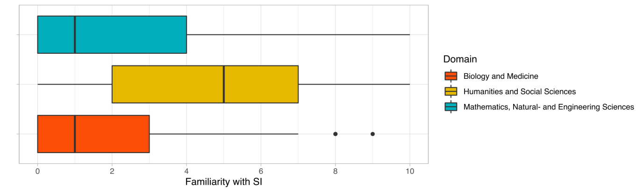

Table 21: Kruskal-Wallis and Pairwise Wilcoxon rank sum test results on SI-Familiarity by research domains

|  |
| --- |
| Kruskal-Wallis rank sum test:  data: familiarWithSI.response. by domain  Kruskal-Wallis chi-squared = 45.694, df = 2, p-value = 1.196e-10  Pairwise comparisons using Wilcoxon rank sum test with continuity correction:    Biology and Medicine  Humanities and Social Sciences 2.0e-09  Mathematics, Natural- and Engineering Sciences 1  Humanities and Social Sciences  Humanities and Social Sciences -  Mathematics, Natural- and Engineering Sciences 2.8e-07  -- P value adjustment method: bonferroni  **RESULT**   * H2: K-W test with a p-value way below α shows we can reject the null hypothesis. There is a statistically significant association between the familiarity with SI and research domains. However, the only significant difference is yielded for Humanities and Social Sciences, compared to the other two domains (P-W). |

### Motivation to improve the human condition & direct social outcomes

As previously discussed in section 4.1.1, SI is per definition built upon its focus on new social practices or actions in a social context that address issues/needs better than already established approaches[[23]](#footnote-23). SI is a socially transformative concept but it does not have to originate from a socially-driven motivation; purely academic research questions can also lead to socially innovative outcomes. However; we expect that

* H3: the higher the motivation to *improve human condition/welfare* is, the higher the chances of direct contribution of the project results are to new or better services, products, processes, or ways of doing things when targeting
  + the general population,
  + specific social groups (e.g., women/men/non-binary, youth/elderly; migrants; or minorities/indigenous people), or
  + NGOs, advocacy, or other civil society groups[[24]](#footnote-24).

Figure 24: Relation between the motivation to improve the human condition/welfare and the direct contribution of the project results towards...

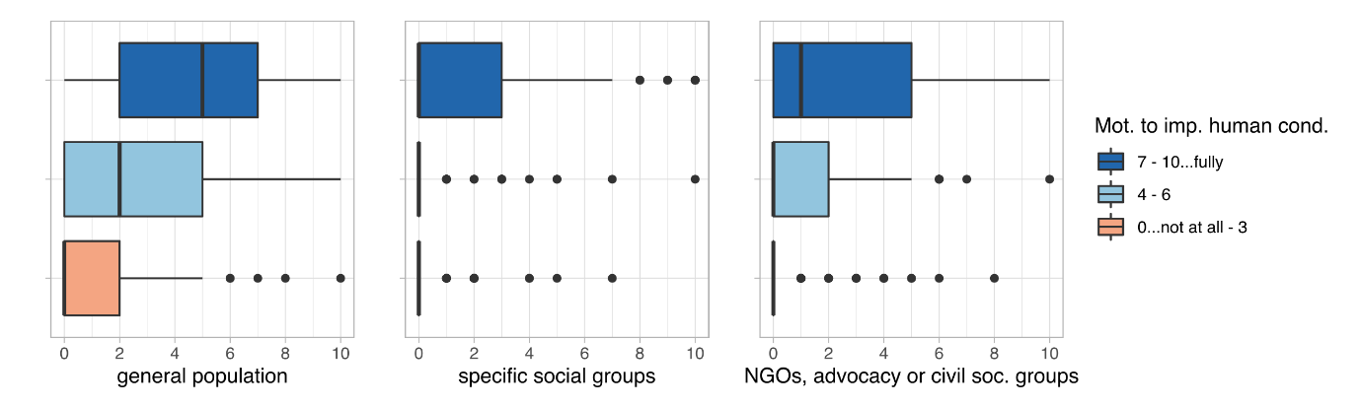

There is some indication that a high *motivation to improve the human condition/welfare* may relate to direct contributions to the target groups of funded research projects (see Figure 24). A deeper analysis of this variable shows statistically significant correlations with each of the outcome variables (p-values < 0.05, see Table 21). The strongest correlation is a moderate positive correlation with the *direct contribution to new or better services, products, processes, or ways of doing things* that were targeted towards the **general population** (rho ≈0.5) [H3.1]. Direct contributions for *specific social groups* and *NGOs, civil society organisations* are correlating relatively weaker (rho is 0.34 and 0.31, respectively) in comparison [H3.2, H3.3]. As anticipated, the motivation to generate an impact outside of academia seems to have a significant relationship with the direct outcomes for specific social groups; despite those associations being not particularly strong per se, it may be to revisit them later in testing hypotheses.

Table 22: Correlation matrix between the motivation to improve the human condition/welfare and the direct contribution of the project results to target groups

|  |
| --- |
| Correlation:  Mot.to imp. human cond. General popul. Spec. social gr.  Mot.to imp. human cond. 1.00 0.51 0.32  General popul. 0.51 1.00 0.38  Spec. social gr. 0.32 0.38 1.00  NGOs, civ. soc. gr. 0.33 0.42 0.55  NGOs, civ. soc. gr.  Mot.to imp. human cond. 0.33  General popul. 0.42  Spec. social gr. 0.55  NGOs, civ. soc. gr. 1.00  Sample Size:  Mot.to imp. human cond. General popul. Spec. social gr.  Mot.to imp. human cond. 355 350 342  General popul. 350 355 344  Spec. social gr. 342 344 347  NGOs, civ. soc. gr. 348 350 347  NGOs, civ. soc. gr.  Mot.to imp. human cond. 348  General popul. 350  Spec. social gr. 347  NGOs, civ. soc. gr. 353  P-Values:  Mot.to imp. human cond. General popul. Spec. social gr.  Mot.to imp. human cond. 0 0  General popul. 0 0  Spec. social gr. 0 0  NGOs, civ. soc. gr. 0 0 0  NGOs, civ. soc. gr.  Mot.to imp. human cond. 0  General popul. 0  Spec. social gr. 0  NGOs, civ. soc. gr.  **RESULT**   * H3.1: the p-value < α, i. e. there is a statistically significant association between the motivation to human condition and the production of better services, product, etc. for the general population (correlation is also moderately strong, rho ≈ 0.5). * H3.2 and H3.3: are returning similar p-values, both smaller than α. There is a statistically significant weak correlation (0.3) with production of better services, etc. and motivation to improve the human condition/welfare. |

### Intention to affect change outside of academia and the nature of the transdisciplinary involvement

Following the dependence of the *familiarity with SI* on the *research domains* (cf. analysis in section 4.1.2), examining the link between the intention to generate impacts outside of academia and research domains is a logical next step in trying to understand differences between those domains with regard to SI. The survey question relating to the *intention to benefit a social group outside of academia* (see section 3.3 for a detailed analysis) is designed to measure one of the important non-academic drivers of socially innovative research. We expect that

* H4.1: the motivation to *generate an immediate and intended benefit for the general population or a specific non-academic target group* depends on the research domain.

Figure 25: Deliberative design of the research for the benefit of non-academic groups among scientific domains

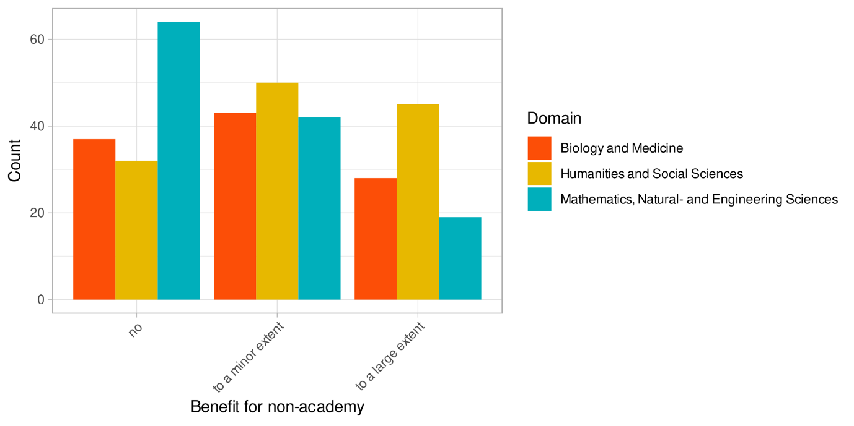

Judging by the descriptive analysis, research domains do seem to have different attitudes when it comes to deliberately planning benefits for target groups outside of academia (cf. Figure 25).

The statistical analysis confirms that the deliberate approach to benefit target groups outside of academia shows a statistically significant difference between different domains (K-W: 𝛘2 = 21.6, df = 2, p-value < 0.05; see Table 22). While there is a statistically significant difference between SSH (Humanities and Social Sciences) and Physical Sciences as well as between Biology & Medicine and Physical Sciences (P-W with Bonferroni correction, p-value < 0.05 for both), there is no statistically significant difference between SSH and Biology & Medicine (P-W with Bonferroni correction, p-value > 0.05).

Table 23: Kruskal-Wallis and Pairwise Wilcoxon rank sum test results on research domain dependency of deliberative research design to benefit social groups outside of academia

|  |
| --- |
| Kruskal-Wallis rank sum test  Kruskal-Wallis chi-squared = 21.623, df = 2, p-value = 2.017e-05  Pairwise comparisons using Wilcoxon rank sum test with continuity correction  Biology and Medicine  Humanities and Social Sciences 0.247  Mathematics, Natural- and Engineering Sciences 0.016  Humanities and Social Sciences  Humanities and Social Sciences -  Mathematics, Natural- and Engineering Sciences 1.4e-05  -- P value adjustment method: bonferroni  **RESULT**   * H4.1: K-W test shows a p-value below α, which indicates the rejection of the null hypothesis: there is a difference between different research domains in terms of intention to benefit non-academic target groups. The P-W test shows a statistically significant difference between each research domain pairing (except the pairing of Biology & Medicine and SSH). |

SI-research postulates to create more socially robust and accepted sustainable solutions than conventional approaches. One of the ways to contribute to such solutions is the transdisciplinary engagement and inclusion of stakeholder groups, i. e. often societal actors in the research process. That said, not every transdisciplinary approach follows the same standards; two of the more important parameters are *how central their involvement in the study was* and the *nature of their involvement*. The *nature of involvement* indicates the scope of the interaction with the stakeholders, which ranges from a *simple contributory involvement* to a full-scale *co-creation* approach*[[25]](#footnote-25)*. Numerous sources indicate that the deeper the involvement, the better the generated results in terms of relevance, applicability and uptake[[26]](#footnote-26). Therefore, we assume that

* H4.2: *the nature of the transdisciplinary involvement of target groups in the research projects is all the more pivotal the higher the level of deliberate planning of benefits for the target group(s)*.

Figure 26: Relation between the deliberate design for benefits for and the nature of involvement of target groups outside academia

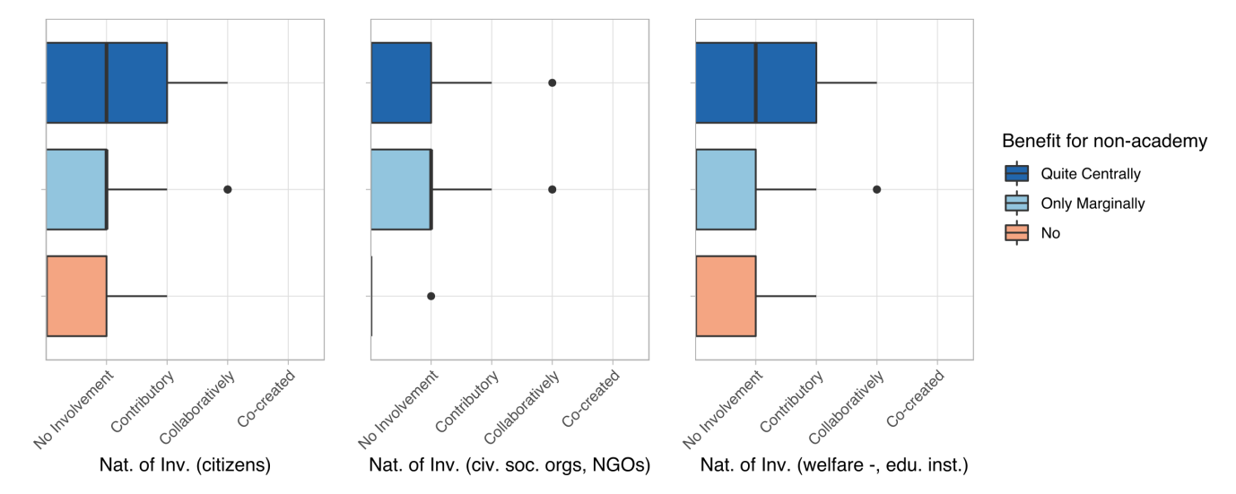

The *nature of involvement* of specific groups indicates how deep the involvement of those groups was in the project (for a detailed analysis of the variable see section 3.4.1). We selected three different societal groups*,* namely *citizens*, *civil society organisations & NGOs*, and *welfare & educational institutions* to test the presented hypothesis.

Figure 26 suggests that there is no or only a small correlation between the intent to create direct *benefits for target groups* and the *nature of involvement* of those target groups. Looking more closely at the three selected societal target groups, it turns out that the correlation between benefit-orientation and the *nature of involvement* of **citizens** as well as **civil society organisations & NGOs** is very weak (rho < 0.15 for each; relation is displayed in Table 23) and not statistically significant (p-value > 0.05 for each pairing). Only the relation between the *nature of involvement* of the **representatives of welfare and educational institutions** and the benefit-orientation of the project design is significant; still, it shows only a weak correlation (rho ≈ 0.3).

Although we can observe a modest relation, a deliberate design to benefit specific societal groups does not seem to correlate highly with a deeper level of involvement of societal groups in the study, in terms of transdisciplinary engagement. In other words, the intention to create benefits for specific selected groups does not necessarily correlate with more intense engagement practices. Maybe the welfare and education sector is an exception to this, because one can speculate that more deep engagement practices with stakeholder from these two sectors are already more practiced and become better standardised.

Table 24: Correlation matrix between the deliberate planning for benefits for and the nature of involvement of target groups outside academia

|  |
| --- |
| Correlation:  Benefit for non-academy citizens civ. soc. org.  Benefit for non-academy 1.00 0.15 0.05  citizens 0.15 1.00 0.37  civ. soc. org. 0.05 0.37 1.00  welfare inst. 0.31 0.51 0.16  welfare inst.  Benefit for non-academy 0.31  citizens 0.51  civ. soc. org. 0.16  welfare inst. 1.00  Sample Size:  Benefit for non-academy citizens civ. soc. org.  Benefit for non-academy 360 82 51  citizens 82 82 34  civ. soc. org. 51 34 51  welfare inst. 74 41 23  welfare inst.  Benefit for non-academy 74  citizens 41  civ. soc. org. 23  welfare inst. 74  P-Values  Benefit for non-academy citizens civ. soc. org.  Benefit for non-academy 0.1882 0.7077  citizens 0.1882 0.0294  civ. soc. org. 0.7077 0.0294  welfare inst. 0.0077 0.0007 0.4541  welfare inst.  Benefit for non-academy 0.0077  citizens 0.0007  civ. soc. org. 0.4541  welfare inst.  **RESULT**   * H5.1: the intention to benefit society and the nature of involvement of citizen and civil society groups (incl. NGOs) in the study have p-values above 0.05. This means that we are accepting the null hypothesis for each of these, i. e. there is no statistically significant relationship between the two analysed variables. * H5.2: the intention to create benefits for stakeholders from the welfare and education sectors has a statistically significant relationship (α < 0.05) with the nature of involvement, although it correlates relatively weakly (rho=0.3). |

### Involvement of citizens, the familiarity with SI, outcomes, and scalability

SI benefits from a broad spectrum of transdisciplinary involvement that includes different types and depth of the involvement of varying societal groups, as presented in previous sections. The involvement of individual citizens, however, has broader implications in SI theory: firstly, the involvement of citizens allows scientific research to mobilise/capitalise on the social capital of individual experiences, and, secondly, it enables a more democratic research structure. Moreover, the involvement of citizens in the research processes can benefit the civic participation structure in society[[27]](#footnote-27).

Citizen participation is not a given in the SI-related research, though. There are several challenges involved, like the equal treatment of laypersons in the research communities or citizens’ willingness to fully participate. Such challenges might arise from individual perspectives and political settings. Adding organisational challenges into the mix might make a transdisciplinary approach undesirable for all involved parties[[28]](#footnote-28).

As discussed previously, our assumption is that SI is an effective tool to mobilise transdisciplinary aspects to find *better* solutions. In this sense, we expect that researchers who are familiar with and experienced in SI do recognise the benefits of citizen participation and are inclined to not just involve individual citizens in their research but also lend them more central roles, despite the involved challenges. Hence, we propose that

* H6.1: the more highly familiar researchers are with SI, the more they are inclined to involve citizens more centrally in their research.

Figure 27: Relation between SI familiarity and the level of involvement of individual citizens

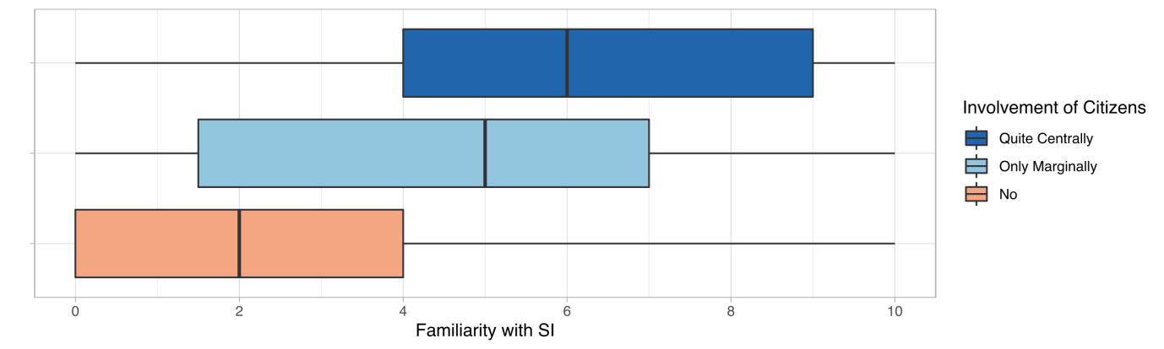

Figure 27 clearly suggests that there is a connection between researchers’ familiarity with SI and how pronounced the involvement of citizens in their research projects is. The statistical analysis confirms that the two correlate moderately positive (rho ≈ 0.4, p-value < 0.05; see Table 24). Individual citizens are more likely to be involved in a project if the researcher is familiar with SI.

Table 25: Correlation test between SI familiarity and the level of involvement of individual citizens

|  |
| --- |
| Spearman's rank correlation rho  S = 4652968, p-value = 3.338e-12  alternative hypothesis: true rho is not equal to 0  sample estimates:  rho  0.3598867  **RESULT**   * H6.1: with a p-value < 0.05, we can reject the null hypothesis. This means that there is a significant relationship between researchers’ familiarity with SI and a more central involvement of citizens. The correlation between the variables is approx. 0.35 and thus fairly modest. |

Transdisciplinary approaches are often applied to capitalise on the ability of non-academic actors to address a previously unknown or only partially explored issue. The *nature of involvement* is an important indicator of what kind of role non-academic participants do play. We assume that

* H6.2: the higher the level of involvement, the higher the chances of addressing a previously unknown (or only partially explored) issue[[29]](#footnote-29).

Figure 28: Relation between the nature of involvement of specific societal actors and groups with the novelty of the addressed issue

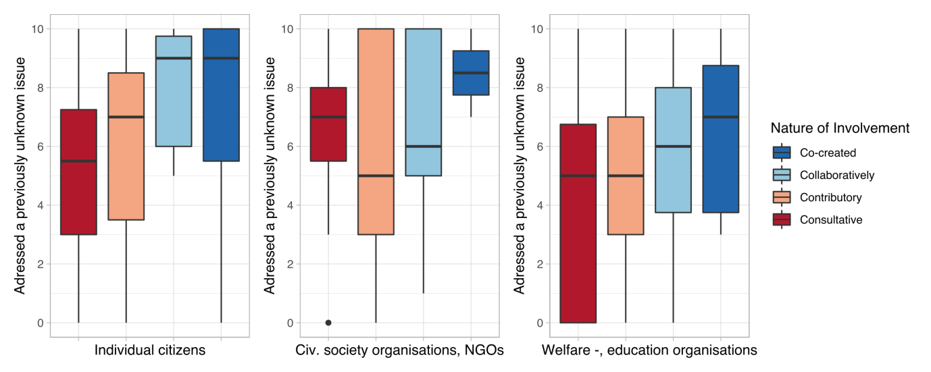

Figure 28 does not convey a clear picture in terms of gauging a relation between the *nature of involvement* and the various societal groups. A statistical analysis shows (see. Table 25) that the *nature of involvement* of **citizens** has a statistically significant relationship with the novelty of the addressed issue (p-value < 0.05). That said, it is a rather weak positive correlation (rho ≈ 0.3). The correlations with the other societal groups, i. e. **civil society organisations** (incl. NGOs) and **welfare-providing and educational organisations**, are even weaker (rho < 0.25).

In this sense, the transdisciplinary involvement does not strongly translate into addressing previously unknown issues.

Table 26: Correlation matrix between the nature of involvement of specific societal actors and groups with the novelty of the addressed issue

|  |
| --- |
| Correlation:  Add. an unknown issue citizens civ. soc. org.  Add. an unknown issue 1.00 0.31 0.02  citizens 0.31 1.00 0.37  civ. soc. org. 0.02 0.37 1.00  welfare inst. 0.24 0.51 0.16  welfare inst.  Add. an unknown issue 0.24  citizens 0.51  civ. soc. org. 0.16  welfare inst. 1.00  Sample Sizes:  Add. an unknown issue citizens civ. soc. org.  Add. an unknown issue 302 73 47  citizens 73 82 34  civ. soc. org. 47 34 51  welfare inst. 61 41 23  welfare inst.  Add. an unknown issue 61  citizens 41  civ. soc. org. 23  welfare inst. 74  P-Values:  Add. an unknown issue citizens civ. soc. org.  Add. an unknown issue 0.0070 0.8955  citizens 0.0070 0.0294  civ. soc. org. 0.8955 0.0294  welfare inst. 0.0644 0.0007 0.4541  welfare inst.  Add. an unknown issue 0.0644  citizens 0.0007  civ. soc. org. 0.4541  welfare inst.  **RESULT**   * H6.2: the novelty of the addressed issue has a significant relationship only with the involvement of the citizens (p < 0.05). However, the correlation coefficient is 0.31 and thus fairly modest. |

Another expectation from stronger forms of participatory involvement is to develop wider impacts and scalable solutions[[30]](#footnote-30). The central involvement of the citizens in the study should allow the creation of more widely applicable results and increased impacts for the involved individuals. In this sense, we expect that

* H6.3: the *more* *central the involvement of individual citizens* is, the
  + higher scalability of the results[[31]](#footnote-31),
  + the more *deeper/better understanding of a specific social issue* are generated, and
  + the higher the emancipatory impact of the study on participating groups are.

Figure 29: Relation between citizens' level of involvement and selected outcome variables

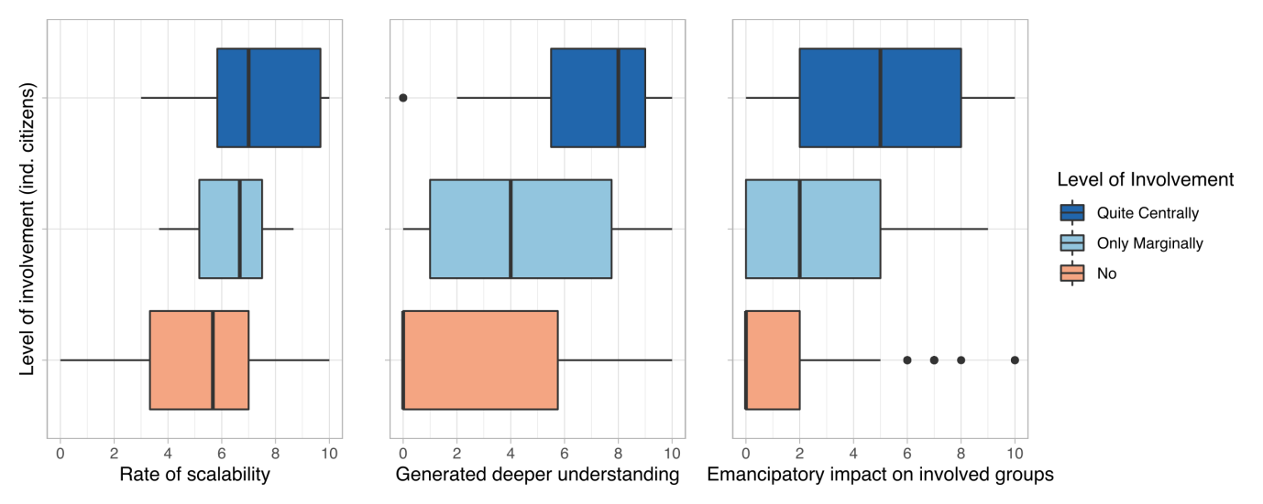

From Figure 29, we can partly derive that there is a relationship between the level of involvement of citizens and the generated results, especially for scalability. Indeed, as the statistical analysis shows (cf. Table 26), scalability seems to be rated slightly higher in research projects where citizens were involved centrally (rho ≈ 0.35, p-value < 0.05) [a].

*Generating a better/deeper understanding* as well as *emancipatory* impact on the involved societal groups seem to be correlating relatively higher (rho > 0.45, p-value < 0.05 each) [b, c].

Hence, we can say that higher levels of *transdisciplinary involvement of the citizens* have a statistically significant relationship with the *scalability of results*, a *deeper/better understanding of the studied issue*, and the *emancipatory impact* on the participating societal actors.

Table 27: Correlation matrix between citizens' level of involvement and selected outcome variables

|  |
| --- |
| Inv. of citizens Scalability Gen. understanding  Inv. of citizens 1.00 0.33 0.39  Scalability 0.33 1.00 0.35  Gen. understanding 0.39 0.35 1.00  Emancip. impact 0.43 0.41 0.65  Emancip. impact  Inv. of citizens 0.43  Scalability 0.41  Gen. understanding 0.65  Emancip. impact 1.00  n  Inv. of citizens Scalability Gen. understanding  Inv. of citizens 353 118 279  Scalability 118 121 114  Gen. understanding 279 114 286  Emancip. impact 267 115 266  Emancip. impact  Inv. of citizens 267  Scalability 115  Gen. understanding 266  Emancip. impact 273  P  Inv. of citizens Scalability Gen. understanding  Inv. of citizens 3e-04 0e+00  Scalability 3e-04 1e-04  Gen. understanding 0e+00 1e-04  Emancip. impact 0e+00 0e+00 0e+00  Emancip. impact  Inv. of citizens 0e+00  Scalability 0e+00  Gen. understanding 0e+00  Emancip. Impact  **RESULT**   * H6.3: the level of involvement of non-academic actors seems to have a statistically significant relationship with scalability, the generation of better understanding, and an emancipatory impact, as the p-values are smaller than 0.05 for each of these, although at a weak to moderate level of correlation. |

### Intended type of change & transdisciplinary aspects

Another question of interest concerns outcomes, i. e. whether the involvement of different societal actors increase the chances for direct impacts on specific groups. Presumably, the nature of involvement of the societal groups does correlate with intended effects. Specifically, we expect that

* H7: a higher order of involvement corresponds with a higher level of intended effects on a specific societal group.

Figure 30: Correlation between the nature of transdisciplinary involvement and intended effects

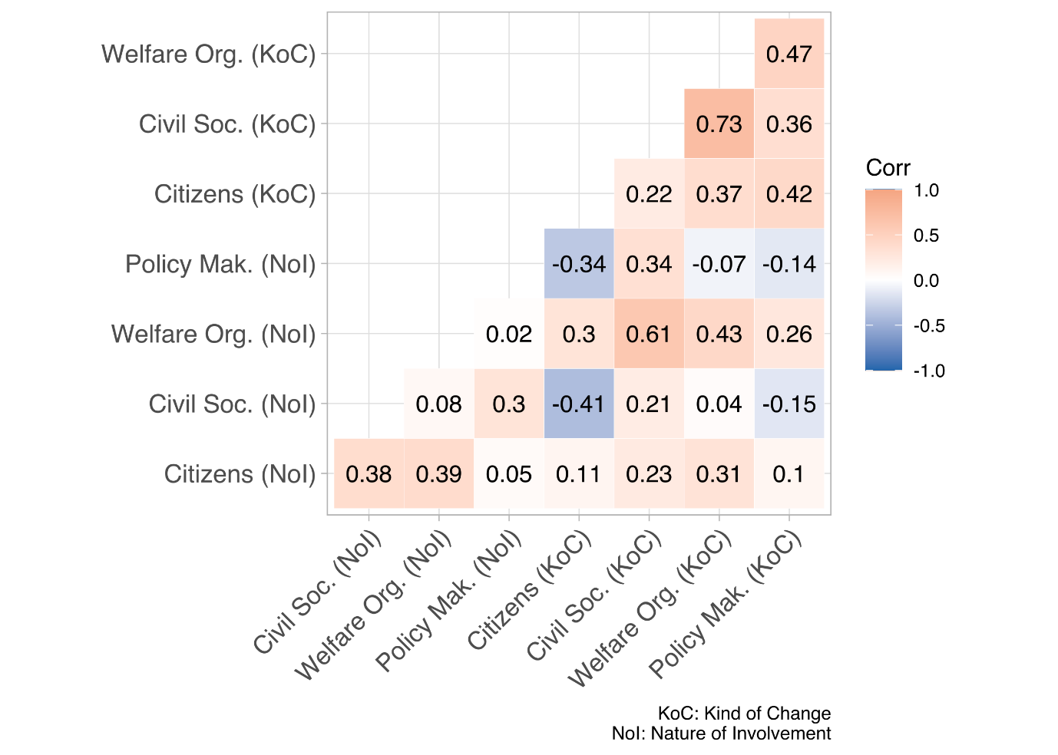

As Figure 30 shows, the *nature of involvement* (NoI) of a specific societal group does not necessarily correlate highly with the intended effects on that specific group. For example, the *nature of involvement* regarding **citizens** does not correlate highly with the *kind of change* (KoC) intended for this target group (rho = 0.11, p-value < 0.05); rather, the NoI shows stronger correlations with the intended *kind of change* for **welfare organisations**and for**civil society groups** (rho = 0.31 and 0.23, respectively, p-value = 0.05). Similar results can be observed for other societal groups.

The *nature of* *involvement* of**welfare organisations** correlates rather highly with the *kind of change* for **civil society organisations** (rho = 0.61, p-value < 0.05), which is only slightly lower than with the *kind of change* for **welfare organisations**.

Despite such stronger correlations, also negative ones can be observed, for instance the *nature of involvement* of **civil society organisations** with the intended *kind of change* for **citizens** (rho = -0.41, p-value < 0.05).

### The motivation to improve the human condition & the effects on target groups

*Intention and agency* are one of the pillars of the concept of SI. Hence, effects associated with SI should correspond to researchers’ initial motivation when planning to improve the human condition/welfare. We expect that

* H8: there is a relation between high levels of *motivation to improve the human condition/welfare* and the degree of contributions to …
  + a better understanding of a social issue,
  + a capability building for targeted groups to tackle similar issues, and
  + play an emancipatory role for the involved groups.

Figure 31: Relation between the social impact statements and the motivation to improve the human condition

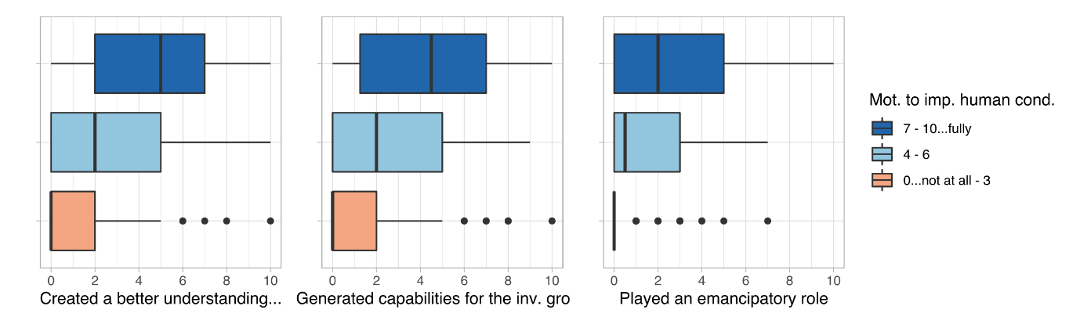

Based on Figure 31, a strong motivation to improve the human condition/welfare does seem to have an effect on the generated impact. The statistic analysis confirms this impression: motivation moderately and positively correlates with each of the analysed impact statement variables (rho > 0.45 each; cf. Table 27).

Table 28: Correlation matrix between the social impact statements and the motivation to improve the human condition

|  |
| --- |
| Correlation:  Mot. to imp. human cond. gen. understanding  Mot. to imp. human cond. 1.00 0.41  gen. understanding 0.41 1.00  gen. capabilities for the soc. gr. 0.45 0.58  played emancipatory role 0.44 0.65  gen. capabilities for the soc. gr.  Mot. to imp. human cond. 0.45  gen. understanding 0.58  gen. capabilities for the soc. gr. 1.00  played emancipatory role 0.71  played emancipatory role  Mot. to imp. human cond. 0.44  gen. understanding 0.65  gen. capabilities for the soc. gr. 0.71  played emancipatory role 1.00  Sample Size:  Mot. to imp. human cond. gen. understanding  Mot. to imp. human cond. 355 281  gen. understanding 281 286  gen. capabilities for the soc. gr. 285 269  played emancipatory role 268 266  gen. capabilities for the soc. gr.  Mot. to imp. human cond. 285  gen. understanding 269  gen. capabilities for the soc. gr. 290  played emancipatory role 268  played emancipatory role  Mot. to imp. human cond. 268  gen. understanding 266  gen. capabilities for the soc. gr. 268  played emancipatory role 273  P-Values < 0.05  **RESULT**   * H8: the *motivation to improve human condition/welfare* has p-values smaller than α with regard to scalability, generating a better understanding, and an emancipatory impact. The correlation with each of those returns a rho greater than 0.4. |

# References

Cargo, M., & Mercer, S. L. (2008). The Value and Challenges of Participatory Research: Strengthening Its Practice. *Annual Review of Public Health*, *29*(1), 325–350. https://doi.org/10.1146/annurev.publhealth.29.091307.083824

Lu, Y., Cohen, I., Zhou, X. S., & Tian, Q. (2007). Feature selection using principal feature analysis. *Proceedings of the 15th International Conference on Multimedia - MULTIMEDIA ’07*, 301. https://doi.org/10.1145/1291233.1291297

Moulaert, F., MacCallum, D., Mehmood, A., & Hamdouch, A. (2013). *The International Handbook on Social Innovation*. Edward Elgar Publishing. https://doi.org/10.4337/9781849809993

1. The selection was limited to the most relevant instruments, i. e. *project funding* (*Div. I-III* and *special*), *Sinergia*, and *Interdisciplinary projects* – their respective number of survey participants is 305, 45, and 11. [↑](#footnote-ref-1)
2. The term scientific domain is used to refer to the overarching categories of scientific disciplines. SNSF documents already include a specific classification system which we have followed throughout the analysis process, we have also tried to stay consistent with colors associated with each scientific domain on different visualisations. Those categories are as follows:

   Biology and Medicine

   Mathematics, Natural –, and Engineering Sciences

   Social Sciences and Humanities [↑](#footnote-ref-2)
3. cf. *What is transdisciplinary research?* at <https://naturalsciences.ch/transdisciplinarity> [last accessed: March 2022] [↑](#footnote-ref-3)
4. To reduce the overall time needed to fill in the online questionnaire, filters based on responses to previous questions were used. This is an example of such a filter – only those participants would actually get to self-assess their project’s contribution to SI who were at least moderately familiar with the concept of SI (5 or higher). [↑](#footnote-ref-4)
5. A statistical model has been built to assess the weight of SI with the help of important surevey variables. [↑](#footnote-ref-5)
6. (Cargo & Mercer, 2008) [↑](#footnote-ref-6)
7. provide information via interviews, online questionnaires, etc. [↑](#footnote-ref-7)
8. consultative + contributing through collecting data, validating data, disseminating results, etc. [↑](#footnote-ref-8)
9. contributory + interpreting data and/or drawing conclusions [↑](#footnote-ref-9)
10. collaborative + participated in designing study and/or determining objectives [↑](#footnote-ref-10)
11. For the latter, see Leemann and Stutz (2008). Geschlecht und Forschungsförderung. Synthesebericht. SNSF; http://www.snf.ch/SiteCollectionDocuments/Web-News/news\_081125\_Synthesebericht\_GEFO.pdf [↑](#footnote-ref-11)
12. http://genderedinnovations.stanford.edu/methods/concepts.html [↑](#footnote-ref-12)
13. e. g. women/men/non-binary, youth/elderly; migrants; or minorities/indigenous people [↑](#footnote-ref-13)
14. such as schools, kindergartens, hospitals, or care centres [↑](#footnote-ref-14)
15. See Frank Moulaert, Diana MacCallum, and Jean Hillier, ‘Social Innovation: Intuition, Precept, Concept, Theory and Practice’, in *The International Handbook on Social Innovation*, by Frank Moulaert et al. (Edward Elgar Publishing, 2013), 13–24, https://doi.org/10.4337/9781849809993.00011.P.13 [↑](#footnote-ref-15)
16. A detailed analysis of these variables can be found in section 3.3 Intention & Agency*.* [↑](#footnote-ref-16)
17. After the consideration of dominant variable types and distributions, as well as the often non-linear relationship between variables, the Spearman correlation method was chosen to test for correlations. The *correlation coefficient* is indicated by the English spelling of the common symbol of Spearman’s rank correlation coefficient symbol **ρ**, i. e. **rho**. The reason for this is to clearly distinguish between the very similar-looking **ρ (rho)** and **p**, as in the **p-value** that is often shown in parentheses. [↑](#footnote-ref-17)
18. Study-wide, the α value is 0.05. [↑](#footnote-ref-18)
19. Research domains are the overarching categories of scientific disciplines. There are different categorisation approaches to cluster disciplines. We are using the SNSF’s categorisation which comprises three distinct clusters, namely *Biology and Medicine*; *Humanities and Social Sciences*; and *Mathematics, Natural -, and Engineering Sciences*. [↑](#footnote-ref-19)
20. See Klaus Schuch, ‘The Contribution of Social Sciences and Humanities to Social Innovation.’, in *Atlas of Social Innovation – 2nd Volume: A World of New Practices.*, by Jürgen Howaldt et al. (München: oekoem verlag, 2019), 94–97. for an analysis of the contribution SSH fields offer to SI and Caroline Paunov, Sandra Planes-Satorra, and Tadanori Moriguchi, ‘What Role for Social Sciences in Innovation?: Re-Assessing How Scientific Disciplines Contribute to Different Industries’, OECD Science, Technology and Industry Policy Papers, vol. 45, OECD Science, Technology and Industry Policy Papers, 17 November 2017, https://doi.org/10.1787/8a306011-en. for different types of contributions from different disciplines to innovation in a broader sense. [↑](#footnote-ref-20)
21. The Kruskal-Wallis method is a non-parametric alternative to ANOVA [↑](#footnote-ref-21)
22. Pairwise Wilcoxon rank sum test is a non-parametric substitute to the pairwise t-test. [↑](#footnote-ref-22)
23. See Jürgen Howaldt, ‘New Pathways to Social Change – Creating Impact through Social Innovation Research’, in *Fteval Journal for Research and Technology Policy Evaluation Issue 48/July 2019 - Proceedings of the Conference ‘Impact of Social Sciences and Humanities for a European Research Agenda Valuation of SSH in Mission-Oriented Research’* (Impact of Social Sciences and Humanities for a European Research Agenda Valuation of SSH in mission-oriented research, fteval - Platform for Research and Technology Policy Evaluation, 2019), 37–48, https://doi.org/10.22163/fteval.2019.365.for a detailed definition. [↑](#footnote-ref-23)
24. For a detailed analysis of the variables, see Section 6 Outcome Orientation*.* [↑](#footnote-ref-24)
25. We differentiate between four levels of *nature of involvement:* consultative (=provide information via interviews, online questionnaires, etc.); contributory (= consultative + *contributing through collecting data, validating data, disseminating results, etc.*); collaboratively (=contributory + *interpreting data and/or drawing conclusions*); co-creating (=collaborative + *participated in designing study and/or determining objectives*). See Kaisler, R. E. and Missbach, B. (2020). Co-creating a patient and public involvement and engagement ‚how to guide‘ for researchers. Research Involvement and Engagement 6(32). **[https://doi.org/10.1186/s40900-020-00208-3](https://doi.org/10.1186/s40900-020-00208-3" \t "_blank).** Shirk, J. L. et al. (2012). Public participation in scientific research: a framework for deliberate design. Ecology and Society 17(2). [↑](#footnote-ref-25)
26. See for example p. 428 in Wolfram Mauser et al., ‘Transdisciplinary Global Change Research: The Co-Creation of Knowledge for Sustainability’, *Current Opinion in Environmental Sustainability* 5, no. 3–4 (September 2013): 420–31, https://doi.org/10.1016/j.cosust.2013.07.001. [↑](#footnote-ref-26)
27. See Nishat, ‘How Social Innovation Can Support Citizen Participation’, *Open Access Government* (blog), 4 October 2019, https://www.openaccessgovernment.org/citizen-participation/67481/. [↑](#footnote-ref-27)
28. For a detailed analysis of the drivers and barriers in citizen involvement, see Mária Svidroňová et al., *Co-Creation and Citizen Involvement in Social Innovation: A Comparative Case Study across 7 EU-Countries*, 2015. [↑](#footnote-ref-28)
29. For a detailed exploration of the variable, see section 3.6: Outcome Orientation. [↑](#footnote-ref-29)
30. For a brief discussion about the scale of the research and scalability of the research results in the context of citizen participation, see P. 56 in Svidroňová et al., *Co-Creation and Citizen Involvement in Social Innovation: A Comparative Case Study across 7 EU-Countries*. [↑](#footnote-ref-30)
31. The concept of scalability has been operationalised under 3 different categories in the survey (deep -, out -, and up scalability), however, after a dimension reduction process in the analysis (explanatory and confirmatory factor analysis), it has been decided to compile the sub-variables of scalability into one single scalability variable because of the similarity of their explained variances. Either because of the similarity of concepts or because of the lack of the knowledge on different forms of scalability the responses under different categories were highly similar (or because of common method bias). [↑](#footnote-ref-31)